Cavendish View School
Safeguarding
&
Child Protection
Policy
&
Procedures

Last update: January 2022
Update Due: January 2023

Contents

Part One: Policy Statement and Principles
Introduction
Definitions
Named staff with specific responsibilities for child protection
Framework underpinning the policy
Safeguarding roles and responsibilities
Sources of support
DSL availability
Transfer of CP files
Part Two: What to do if you are worried about a child
School Child Protection Procedures
Contextual safeguarding
DSL considerations
Feedback for Staff
Consent for Referrals to CSC and Early help
Thresholds for Referrals to CSC (s17 and s47)
Early Help
Decision making rationales and Feedback
Listening to children and managing disclosures
Part Three: Child Abuse and Neglect
Definitions and Indicators

Part Four: Children in Specific Circumstances
So Called ‘Honour Based’ Violence and Abuse
Forced Marriage
Female Genital Mutilation
Child Sexual Exploitation
Modern Slavery and Human Trafficking
Children Affected by gangs and youth Violence Criminal Exploitation (County Lines)
Serious Violence
Peer on Peer Abuse
Sexual Violence and Harassment between Children in School Bullying
Self-Harm and Suicide
Domestic Abuse
Homelessness
Radicalisation and Extremism
Sexting
Children Missing Education
Young Carers

Part Five: Children Looked After & those with SEN/additional needs
Children Looked After
Private Fostering
Children with Special Educational Needs and Disabilities

Part Si
x: A Safer School

Safer Recruitment & Updates to KCSIE January 2021

Staff Training and Induction

Whistle Blowing

Management of Allegations

Part

Seven
:

Appendices

Talking and Listening to Children

Body Maps

Internal

notification of concern to the DSL

Record of professional/parent contact

Information/concerns ‘checklist’
KCSIE – September 2021 Updates

Part One: Policy Statement and Principles

Introduction
Ambito Care and Education is committed to the safety and protection of all children and young people living in or attending our establishments. We strive to ensure the provision of a safe and caring environment in which children and young people can develop educationally, socially and emotionally, safe from fear and free from harm.
This policy is one of a series in the Ambito Care and Education’s integrated safeguarding portfolio. This includes policies for child protection, staff code of conduct, recruitment and selection, managing allegations against staff, complaints and representations, positive behaviour support, data protection and online safety.
Every member of staff within Ambito Care and Education has a shared responsibility for safeguarding however; there are specific roles in relation to safeguarding that all staff should be aware of. A member of the Ambito Care and Education Senior Leadership Team has specific responsibility for safeguarding across Ambito Care and Education. The Director and Safeguarding Lead with this responsibility is Kelley Fray in her absence Chris Brown and this role is supported by Group Safeguarding Co-ordinator Michael Albero. Together they have responsibility for ensuring that all policies and procedures across the group are robust and consistently applied.

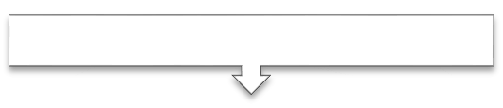
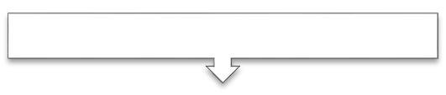
Safeguarding Structure
Designated Safeguarding Leads
Safeguarding Co
-
ordinator
Designated Safeguarding Leads
Group Safeguarding Lead
Ambito Care and Education Board of Directors
Staff  Teams |  | Staff  Teams |  | Staff  Teams |  | Staff  Teams |  | Staff  Teams |  | Staff  Teams

At Cavendish View School safeguarding permeates all aspects of school life and is everyone's responsibility; the school forms part of a wider safeguarding system. In order to fulfil our responsibilities we adopt a child-centred approach. This means that:

- Safeguarding systems and procedures are oriented around the wishes, feelings and best interests of children;
- We seek to give children a 'voice', listen to what they say, take them seriously and work collaboratively in order to meet their needs.

Our school aims to provide a positive, stimulating, caring and safe environment which promotes the social, physical, emotional and moral development of each child. We work hard to maintain a safeguarding ethos and culture whereby children feel safe and are safe whilst at school, and on their way to and from school.
This policy applies to everyone in our school and it should be read and understood alongside the following School/Ambito Care and Education policies:

- Managing Allegations against staff
- Anti-Bullying policy
- School Policy on the Education of Looked After Children
- Online Safety
- Staff Recruitment and Selection
- Intimate Care
- Positive Behaviour Support
- Whistle-blowing
- Code of Conduct

Definitions
Child(ren) means everyone under the age of 18. Statutory guidance 'Working Together to Safeguard Children' (2018) defines safeguarding and promoting welfare as: - protecting children from maltreatment;
- preventing impairment of children's health or development;
- ensuring that children grow up in circumstances consistent with the
- provision of safe and effective care; and
- taking action to enable all children to have the best outcomes.

Therefore, 'safeguarding' includes but is about much more than 'child protection'. However, all staff are aware of the school’s collective responsibility to act in order to protect children from various potential sources and types of harm:
- Physical, sexual, emotional abuse and neglect;
- Bullying, including online bullying and prejudice-based bullying;
- Racist, disability and homophobic or transphobic abuse;
- Gender-based violence/violence against women and girls;
- Sexual violence and sexual harassment;
- Radicalisation and/or extremist behaviour;
- Child sexual exploitation;
- Criminal exploitation;
- Modern Slavery;
- Trafficking;
- Gang involvement and youth violence;
- The impact of new technologies on sexual behaviour, for example sexting;
- Substance misuse;
- Domestic abuse;
- So-called 'honour-based violence' including female genital mutilation, forced marriage, breast ironing / flattening;
- Fabricated or induced illness (formerly known as 'Munchausen's')
- Poor parenting, particularly in relation to babies and young children.

Named staff with specific responsibility for Child Protection

Academic  Year | Designated Safeguarding Lead | Deputy Designated Safeguarding Lead (s)
2021-2022 | Louise Kelly | Lyndsey Murphy

Framework Underpinning this Policy
This policy and procedures have been written and will be implemented in-line with the safeguarding and child protection procedures established by Liverpool Safeguarding Children Partnership (LSCP) https://liverpoolscp.org.uk. It is also written in accordance with legislation established by the Children Acts 1989 and 2004, the Education Act 2002, Safeguarding Vulnerable Groups Act 2006, The Education (Independent Schools Standards) (England) Regulations 2003, and other core legislation and guidance [the following list is not exhaustive]:

- ‘Working Together to Safeguard Children’ DfE July 2018; https://www.gov.uk/government/publications/working-together-to-safeguard-children--2
- Keeping Children Safe in Education, Statutory guidance for schools and colleges September
2020 & KCSIE – January 2021 updates ;
https://assets.publishing.service.gov.uk/government/uploads/system/uploads/attachment_data/file/912592/Keeping_children_safe_in_education_Sep_2020.pdf

- The Prevent Duty Departmental advice for schools and childcare June 2015 providers; https://www.gov.uk/government/uploads/system/uploads/attachment_data/file/439598/pr event-duty-departmental-advice-v6.pdf

- Guidance for Safer working practice for those working with children and young people in education settings May 2019;
https://www.saferrecruitmentconsortium.org/GSWP%20Sept%202019.pdf

- Information sharing, advice for practitioners providing safeguarding services to children, young people, parents and carers. DfE July 2018; https://assets.publishing.service.gov.uk/government/uploads/system/uploads/attachment_ data/file/721581/Information_sharing_advice_practitioners_safeguarding_services.pdf

- Child Sexual Exploitation – Definition and a Guide (DfE 2017); https://assets.publishing.service.gov.uk/government/uploads/system/uploads/attachment_ data/file/591903/CSE_Guidance_Core_Document_13.02.2017.pdf

- What to do if you’re worried a child is being abused 2015 – Advice for practitioners March
2015;
https://www.gov.uk/government/uploads/system/uploads/attachment_data/file/419604/ What_to_do_if_you_re_worried_a_child_is_being_abused.pdf

- Multi – Agency Practice Guidelines: Female Genital Mutilation (2016) https://www.gov.uk/government/uploads/system/uploads/attachment_data/file/380125/ MultiAgencyPracticeGuidelinesNov14.pdf

- Teacher Standards (2012) https://www.gov.uk/government/publications/teachers-standards

- Counter Terrorism and Security Act 2015 (Inc. the 'Prevent Duty') https://www.gov.uk/government/collections/counter-terrorism-and-security-bill
- Serious Crime Act (2015) http://www.legislation.gov.uk/ukpga/2015/9/contents/enacted
- Children and Social Work Act 2017 http://www.legislation.gov.uk/ukpga/2017/16/contents/enacted
- The Data Protection Act 2018 https://www.gov.uk/government/collections/data-protection-act-2018
- Sexual Violence and sexual harassment between children in schools and colleges. May 2018 https://www.gov.uk/government/publications/sexual-violence-and-sexual-harassmentbetween-children-in-schools-and-colleges
- Children Missing Education September 2016 https://assets.publishing.service.gov.uk/government/uploads/system/uploads/attachment_ data/file/550416/Children_Missing_Education_-_statutory_guidance.pdf

Safeguarding Roles and Responsibilities
School staff have no investigative role where child protection is concerned; this is a matter for children’s social care and the police. However, schools do have a responsibility to provide a safe environment in which children can learn and all staff, including volunteers, have a responsibility to act to safeguard and promote children's welfare.

Some people have specific and/or additional safeguarding responsibilities:

The Proprietary Board
The Proprietary Board take seriously their responsibility under section 11 of the Children Act 2004, section 157 of the Education Act 2002 and Part Two of KCSIE 2021. The proprietors monitor compliance with statutory requirements and identifies areas for improvement. At least annually, the Designated Safeguarding Lead will prepare a safeguarding report to be tabled at a full School Board meeting. Discussions will be recorded and any agreed and/or remedial action(s) documented and followed through, formally and immediately.

The Chair of the School Board is:
Kelley Fray in her absence Chris Brown
The Nominated/Link Safeguarding School Board member is:
Michael Albero

The Principal
- The Principal will ensure that the policies and procedures adopted by the Proprietary Board, particularly concerning referrals of cases of suspected abuse and neglect, are fully implemented and followed by all staff;
- Act as a strategic conduit between the DSLs, the Proprietary Board and Ambito Care and Education on safeguarding matters;
- Be the case manager and liaise with the LA designated officer (LADO) in the event of allegations of abuse being made against a member of staff or volunteer;
- Ensure that a senior member of staff from the leadership team is appointed as the DSL in school and that there is always cover for this role;
- Ensure that the DSL’s access appropriate training which is regularly updated in-line with statutory and LSCP guidance;
- Ensure that sufficient resources and time are allocated to enable staff to discharge their responsibilities;
- Refer cases to the DBS where a person is dismissed or leaves our employment due to risk/harm to a child - this is a legal requirement;
- Lead in such a way as to create an environment where all staff and volunteers feel empowered to raise concerns about poor or unsafe practice and will address any concerns sensitively, effectively and in a timely manner.

Designated Safeguarding Lead (DSL) and Deputy DSL(s)
The DSL and Deputy DSL(s) undertake training and refresher training in-line with statutory requirements in order to ensure that they have the knowledge and skills required to carry out the role. This will include a refresher every 2 years and additional training, reading or attendance at DSL forums on an annual basis.

The Designated Senior Lead's role is described in Keeping Children Safe in Education 2021

Briefly, our DSLs will:
- Refer cases of suspected abuse to children’s social care as required;
- Support staff who make referrals to children’s social care;
- Refer cases to the Channel programme where there is a radicalisation concern and / or support staff who make referrals to the Channel programme;
- Refer cases where a crime may have been committed to the Police, as required;
- Liaise with the Principal to inform him or her of safeguarding and child protection issues, especially ongoing enquiries under section 47 of the Children Act 1989 and any police investigations;
- Liaise with staff ( especially pastoral support staff, school nurse, IT technicians and SENCOs) on matters of safety and safeguarding in school, including whether to make a referral by liaising with relevant agencies;
- Act as a source of advice, support and expertise for all staff;
- As required, liaise with the “case manager” - as per the statutory guidance/KCSiE 2021) and the designated officer(s) at the local authority (LADO) regarding concerns or allegations about a staff member;
- Ensure appropriate representation at and contributions to multi-agency safeguarding meetings by our school, including the provision of written reports in line with LSCP guidance/templates;
- Ensure compliance with best practice and statutory guidance in respect of safeguarding record keeping per se and, in particular, the seeking and passing on of relevant information when children join and leave our school (this includes written acknowledgement of receipt from receiving schools/professionals).
- Consider sharing information with the receiving school or college in advance to the child attending to enable support to be in place when the child arrives at the new setting.
- Take the lead on liaising with other agencies and setting up interagency assessments where Early Help is required.
- Ensure that they understand the unique risks associated with online safety and have the relevant knowledge and up to date capability required to keep children safe whilst they are online at school. They also recognise the additional risks that children with SEN and disabilities (SEND) face online;
- Encourage a culture of listening to children and taking account of their wishes and feelings, among all staff.

Meetings the DSL would attend
Our DSL will attend and contribute to all multi-agency meetings convened by statutory organisations, whether this is Children’s Social Care, the police, health or YOT. They will ensure where required under LSCP procedures that they compile and produce a written report that is in accordance with LSCP procedures. Examples of such meetings would be [this list is not exhaustive].
Initial Child Protection Conference (ICPC)
- Review Child Protection Conference (RCPC)
- Core Group
- Strategy meetings
- Planning Meetings
- Multi Agency Risk Management Meetings (MARMM)
- Care Planning Meeting
- Complex Abuse Meetings

Sources of Support
Name | Designation | Contact Details
Kelley Fray  Chris Brown | Managing Director | 07562 600387  07525717033
Ray Said | LADO | 07841 727309  0151 233 0840/0853
Gary Laville | Group Director of Quality Assurance and Governance | 07526 178467
Michael Albero | Group Safeguarding Coordinator | 07817953095

DSL availability
During term time, during school hours, the DSL or deputy DSL will be available in person, to respond to any enquiries and for staff to discuss any safeguarding concerns.
The Principal’s, DSL’s and Deputy DSLs ‘Out of Office’ email auto reply will also be on during the evenings/weekends to advise who to contact in their absence with regard to any safeguarding matters or enquiries.

During the evenings, weekend or school holidays the school will have an on call system which will direct any enquiries to the Managing Director, Kelley Fray. The Principal, DSL’s and Deputy DSLs ‘Out of Office’ email auto reply will also be on to advise who to contact in their absence with regard to any safeguarding matters or enquiries.

Transferring of Child Protection Files
Where a child leaves our school, the DSL will transfer the child protection file to the DSL at the next school or education setting within 15 working days of the child going off role. The file transfer summary will be completed, the file will be sent separately from the main pupil file and a receipt obtained. The file, if not being hand delivered, will be placed in a double envelope and marked clearly ‘strictly confidential’ and have as the addressee, the name of the Designated Safeguarding Lead.

In addition to transferring the file, the DSL will consider whether it is appropriate to share any information with the DSL at the new school in advance of the child leaving. For example, a child who is the victim of abuse to enable ongoing support or where a child is an alleged perpetrator of abuse and information from the Risk Management Plan is shared to enable appropriate measures to safeguard of other children and to manage risk, to be put in place.

Part Two: What to do if you are worried about a child
No single professional can have a full picture of a child’s needs and circumstances. If children and families are to receive the right help at the right time, everyone who comes into contact with them had a role to play in identifying concerns, sharing information and taking prompt action.
At Cavendish View school we recognise that safeguarding incidents and/or behaviours can be associated with factors outside of school and/or can occur between children outside the school. All staff, but especially the designated safeguarding lead (or deputy) will consider the context within which such incidents and/or behaviours occur. This is known as contextual safeguarding, which simply means assessments of children should consider whether wider environmental factors are present in a child’s life that are a threat to their safety and/or welfare. Any referrals to Children’s social care will provide as much information as possible as part of the referral process so that assessments consider such factors and allow any assessment to consider all the available evidence and the full context of any abuse. Everyone will adhere to the Liverpool Safeguarding Children Partnership Procedures https://liverpoolscb.proceduresonline.com/chapters/contents.html

School Safeguarding & Child Protection Procedures
The Designated Safeguarding Lead will ensure that the school Safeguarding & Child Protection policy is made publicly available and that parents are aware of the fact that all cases of suspected abuse or neglect will be referred to Children's Social Care and the school role within this. That staff know the policy and use it appropriately; it is reviewed and updated regularly along with the Proprietary Board.

What Should Staff/Volunteers Do If They Have Concerns About A Child or Young Person in School | ?
Staff who have any concern about a child, should immediately discuss this with the Designated Safeguarding Lead or the Deputy Designated Safeguarding Lead. Ambito Care and Education staff will record this on the Ambito Care and Education Nourish database as a concern, supply staff will record concerns on the yellow reporting concerns to the DSL pro forma (SEE flowchart on p21). Staff records relating to a concern, must be completed before the end of the school day.

The Designated Safeguarding Lead is: Louise Kelly
The Deputy Designated Safeguarding Lead [s] are: Lyndsey Murphy

It is these senior colleagues who are responsible for taking action where the welfare or safety of children or young people is concerned. If staff are uncertain about whether their concerns are indeed ‘child protection’ then a discussion with their DSL or deputy DSL will assist in determining the most appropriate next course of action:

Staff should never:
- Do nothing/assume that another agency or professional will act or is acting.
- Attempt to resolve the matter themselves,

What should staff do?

The process in our school is that all concerns are verbally reported immediately to the DSL/deputy DSL and then Ambito Care and Education staff will document the concern on the concern section of the Ambito Care and Education Nourish database. Supply staff will document concerns on the yellow ‘internal notification to the DSL’ form (Appendix 3), if no one who is DSL trained is contactable, then the concerns are reported to the next most senior member of staff. Where there are physical injuries evident a body map should be used to record these (Appendix 2) SEE PAGE 18 FOR GUIDANCE.

What should the DSL consider right at the outset?
- Am I dealing with ‘risk’ or ‘need’? (By definition, a child at risk is also a child in need.
However, what is the priority/level and immediacy of risk/need?)

Can the level of need identified be met:
  - Managing any support for the child internally via the school’s own pastoral processes
  - An early help assessment
  - A referral to statutory services as either a child in need or as suffering or likely to suffer significant harm.

Further DSL considerations:

- What resources are available to me/the school and what are their limitations?
- Thresholds guidance indicates that a Child in Need referral needs to be made to Children’s Social Care which requests that an assessment of need be undertaken. (This sits at Level 3 on the LSCP Level of Need Framework. Level 3: Complex Needs/Multi-Agency Response/EHAT. Child has complex needs or multiple needs which require targeted support. Needs should be met by a multi-agency response. Initiate an Early help Assessment EHAT
- Thresholds guidance indicates that the level and/or likelihood of risk such that a child protection referral needs to be made (i.e. a child is suffering or is likely to suffer significant harm. (This sits at Level 4 on the LSCP Level of Need Framework. Level 4: Acute Needs/Statutory Response. Child with significant welfare concerns. Specialist Intervention – Social Worker led. (Child in Need Section 17) (Child Protection Section 47) MARF required.
- The context in which the concern and/or behaviour occurred
- What information is available to me: Child, Parents, Family & Environment?
- What information is inaccessible and, potentially, how significant might this be?
- Who do I/don’t I need to speak to now and what do they need to know?
- Where can I access appropriate advice and/or support?
- If I am not going to refer, then what action am I going to take? (E.g. Early Help, time-limited monitoring plan, discussion with parents/carers or other professionals, recording etc.)

Feedback to Staff Who Report Concerns to the Designated Safeguarding Lead
Rules of confidentiality dictate that it may not always be possible or appropriate for the Designated Safeguarding Lead to feedback to staff who report concerns to them. Such information will be shared on a ‘need to know’ basis only and the Designated Safeguarding Lead will decide which information needs to be shared, when and with whom. The primary purpose of confidentiality in this context is to safeguard and promote the child’s welfare.

Consideration for Referrals to CSC and Thresholds Guidance

The DSL will consider any information received against the thresholds guidance. Where a referral to Children’s Social Care is made, this will clearly outline the concern and link this to the thresholds guidance, the thresholds guidance is available via

https://liverpoolscb.org.uk/assets/1/lscb_levels_of_need_level_indicators.pdf

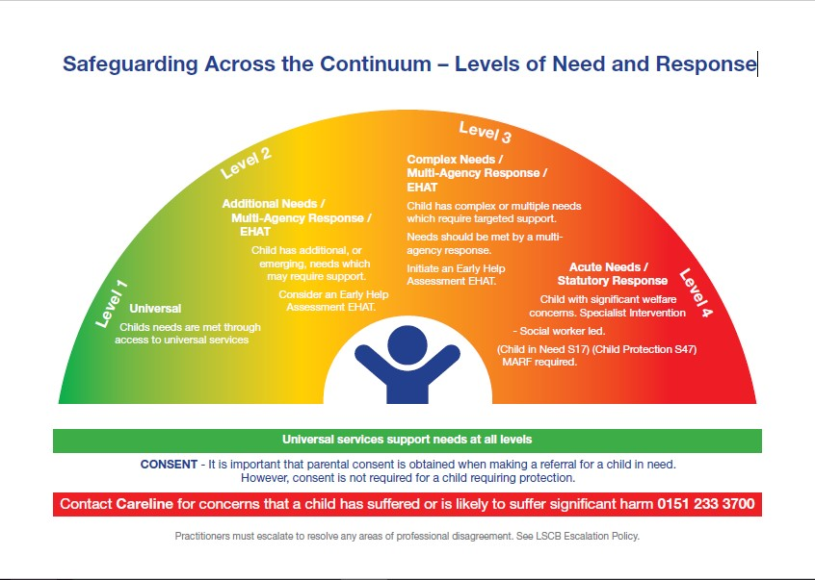

Consent for Referrals to Early Help and Children’s Social Care
At Cavendish View School, we manage sensitive information appropriately and ensure that our practice complies with the requirements and principles of the Data Protection Act 2018, local protocols and national guidance.

We recognise that children are best protected when professionals work effectively together. Fears about sharing information cannot be allowed to stand in the way of the need to safeguarding and promote the welfare of children who are at risk of abuse or neglect. At Cavendish View School, all staff will pass on information they hold and will not make assumptions that someone else will act on their concerns and pass on information.

At our school, we will working openly and honestly with Parents and Carers and seek consent wherever possible, where this is in the best interests of the child/ren. The child/ren will always be our paramount consideration.

Information to safeguard children may be shared with others outside of our School in order to keep them safe. We will always aim to discuss concerns with parents or carers before we share information, but this may not always be possible. If this is the case, the law allows us to share this information without consent.

The Data Protection Act 2018 includes ‘safeguarding children and individuals at risk’ as a condition that allows practitioners to share information without consent:
- Information can be shared legally without consent if a practitioner is unable to gain consent, cannot be reasonably expected to gain consent from the individual, or if to gain consent would place the child at risk.
- Relevant personal information can be shared lawfully if it is to keep a child or individual at risk, safe from neglect of physical, emotional or mental harm, or if it is protecting their physical, mental or emotional wellbeing.

Referrals to Children’s Social Care
Where a Designated Safeguarding Lead (DSL) or Deputy DSL considers in line with thresholds that a referral to Children’s Social Care (CSC) is required, there are two thresholds for (and their criteria) that need to be carefully considered:

Referrals under section 17 (s17)
❖ Is this a Child In Need?

Under section 17 (s.17 (10)) of the Children Act 1989, a child is in need if:
- He is unlikely to achieve or maintain, or to have the opportunity to achieve or maintain, a reasonable standard of health or development, without the provision of services by a local authority;
- His health or development is likely to be impaired, or further impaired, without the provision of such services; (c) He is disabled.

Referrals for Children in Need (s17) will require the consent of parents, therefore, the DSL will make decisions as to who is best placed to have those discussions with parents and ultimately seek their consent.

Where consent is refused, then the DSL must make decisions as to the way forward, this could be:

- To monitor
- To agree with parents achievable goals within set timescales that are reviewed regularly
- To make a referral without consent on the basis that nothing is changing in real terms for the child

It is important to remember when setting and reviewing goals that it is not just about achieving change but maintaining it.

Where a s17 referral is made, a Multi Agency Referral Form (MARF) will be completed on the following website:
https://liverpool.gov.uk/referrals/childrens-social-care-referrals/make-an-urgent-marfreferral/marf-form/

Referrals under section 47 (s47)
❖ Is this a Child Protection Matter?

Under section 47(1) of the Children Act 1989, a local authority has a duty to make enquiries where they are informed that a child who lives or is found in their area:
- is the subject of an Emergency Protection Order;
- is in Police Protection; or where they have;
- reasonable cause to suspect that a child is suffering or is likely to suffer significant harm.

Therefore, it is the ‘significant harm threshold’ that justifies statutory intervention into family life. A professional making a child protection referral under section 47 must therefore provide information which clearly outlines that a child is suffering or is likely to suffer significant harm.
Referrals under section 47 do not require consent, however best practice is that concerns are discussed openly and honestly with parents and they are informed of a referral unless:
- it would cause further significant harm to the child;
- would cause undue delay; • would impede an investigation.
Examples of concerns where you would not discuss with parents prior to referral (this list is not exhaustive)
- Fabricated or Induced Illness,
- Forced Marriage/Honour Based Violence or Abuse
- Intra-familiar sexual abuse

The Welfare of the child is the paramount consideration at all times

Referrals
Anyone can make a referral to Liverpool Children’s Social Care via ‘Careline’ and usually this will be the Designated Safeguarding Lead or any deputy who will make judgements around ‘significant harm’, levels of ‘need’ and when to refer in line with LSCP procedures and thresholds guidance.
‘Careline’ is a 24-7 contact centre for all child social care enquiries and referrals from both the public and professionals. You can contact Careline on: 0151 233 3700 (if a child is at immediate risk call 101 or 999 in an emergency).
You will be asked to follow up your call by submitting an online Multi-Agency Referral Form (MARF) within 1 working day. You will receive an automated acknowledgement once the MARF has been successfully submitted which will include a unique reference number.
Before submitting a MARF it is important that all professionals carefully consider the LSCP ‘Responding to Need Guidance & Levels of Need Framework’:

https://liverpoolscb.org.uk/assets/1/lscb_levels_of_need_level_indicators.pdf

Early Help
Providing early help is more effective in promoting the welfare of children than reacting later.
Early help means providing support as soon as a problem emerges, at any point in a child's life,
from the foundation years through to the teenage years. Early help can also prevent further problems arising.

Effective early help relies upon local agencies working together to:
- identify children and families who would benefit from early help;
- undertake an assessment of the need for early help; and
- provide targeted early help services to address the assessed needs of a child and their family which focuses on activity to significantly improve the outcomes for the child.

Schools are in a position to identify concerns early, provide help for children, and prevent concerns from escalating. Our pastoral system enables us to identify children who may benefit from early help - this means providing support as soon as a problem emerges.
Our Pastoral Team closely monitors and analyses pupil attendance and behaviour via the database and at ITAC meetings. This provides opportunities to discuss individual pupils, highlight/identity any concerns and consider any contextual safeguarding issues thereby enabling us to identify whether early help would be appropriate
After consideration of LSCP’s Responding to Need Guidance & Levels of Need Framework, if Early Help is appropriate, the designated safeguarding lead ( or deputy) will lead on liaising with other agencies in setting up an inter-agency assessment as appropriate. As appropriate, the DSL will delegate to any staff the requirement to support other agencies and professionals in an early help assessment, this may result in staff acting as the Lead Professional. In our school, the DSL will keep such cases under constant review and consideration given to a referral to children’s social care for assessment for statutory services, if the child’s situation does not appear to be improving or is getting worse.

We will do this in partnership with parents and children and other relevant agencies, in-line with locally agreed procedures and protocols.

In this context, Keeping Children Safe in Education 2021, makes it clear that any child may benefit from Early Help, but all school staff should be particularly alert to the potential need for early help for a child who:

- Is disabled and have specific additional needs;
- has special educational needs (whether or not they have a statutory education, health and care plan);
- is a young carer;
- is showing signs of engaging in anti-social or criminal behaviour, including gang involvement and association with organised crime groups;
- is frequently missing/going missing from care of from home;
- is misusing drugs or alcohol themselves;
- is at risk of modern slavery, trafficking or exploitation;
- is in a family circumstance presenting challenges for the child, such as substance misuse,
adult mental health problems and domestic abuse;
- has returned home to their family from care;
- is showing early signs of abuse and/or neglect;
- is at risk of being radicalised or exploited;
- is a privately fostered child.
We recognise that those who are new to school or on a temporary basis, can sometimes pick-up on things and therefore the DSL will ensure that they are aware of reporting systems and have undergone the safeguarding briefing in school on day one as appropriate. Everyone has a responsibility to report concerns and everyone will be listened to and heard if they do so, whatever their role and however trivial or insignificant the concern might seem at face value.

Staff may be required to support other agencies and professionals in an early help assessment and anyone who has a concern about the need for early help for a child/family should liaise with the DSL.

Further information about Early Help is available via:
https://liverpoolscb.org.uk/scp/professionals-volunteers/early-help

You can access links to: EHAT Form and TAF Form

The following is a link to the Early Help Directory which has a parent/carers section and a professionals section which is password protected https://ehd.liverpool.gov.uk

To check if an Early Help Assessment is already ‘open’, contact your local Early Help Hub:

North: T: 0151 233 3637 E: EHLHcorth@liverpool.gov.uk
Central: T: 0151 233 6152 E: EHLHcentral@liverpool.gov.uk
South: T: 0151 233 4447 E: EHLHsouth@liverpool.gov.uk

Early Help assessments are completed on-line and submitted to the Early Help Hub using the on-line form. Initial assessment forms and further review forms can be found at:
Upon submitting your initial assessment to the local hub you will be given a reference number by Liverpool’s Early Help Assessment Co-Ordinator. If an Early Help is already in progress you will be informed at this stage.

Recording Decision Making Rationales and contacts with parents/carers/professionals
The DSL or deputy DSL will make a clear record of any action taken in response to concerns raised, any referrals, and decision-making rationales in the relevant section on the Ambito Care and Education Nourish database. Decision making rationales will clearly state why action has or has not been taken and will be linked to the relevant points and level within the thresholds guidance. The DSL/DDSL will also upload all information and any documentation associated with the referral to the Ambito Care and Education Safeguarding database.
All discussions with parents or professionals in relation to a safeguarding or welfare concern will be recorded in the chronology of contacts on the Ambito Care and Education Safeguarding Database. As per the 7 Golden Rules of Information sharing, information sharing rationales will be recorded in the relevant section. Records will clearly demonstrate, what has been shared, with whom, when and why. Where the DSL asks someone other than the author of the concern to speak to a parent about a concern, that person will record the conversation on the blue professional/parent contact pro forma (appendix 4), hand this to the DSL who will upload it to the system.

CSC Responses to Referrals and Timescales
In response to a referral, Children's Social Care should make a decision, within ONE working day of the referral being made, about the course of action it is taking and should let the referrer know. Children’s Social Care may decide to:
- Provide advice to the referrer and/or child/family;
- Refer on to another agency who can provide services;
- Convene a Strategy Meeting (within five working days);
- Provide support services under Section 17;
- Undertake a Statutory Assessment (completed within 45 working days);
- Convene an Initial Child Protection Conference (within 15 working days of a Strategy Meeting/discussion)
- Accommodate the child under Section 20 (with parental consent);
- Make an application to court for an Order;
- Take no further action.
- Step down to Early Help

Feedback from Children’s Social Care
Upon receiving a referral, Children's Social Care should make a decision about the type of response that will be required to meet the needs of the child within ONE working day. If this does not occur within three working days, the referrer should contact these services again and, if necessary, ask to speak to a line manager to establish progress.
Where the DSL or person making the referral does not agree with the outcome of a referral or with the actions of Children’s Social Care that person will follow the LSCP Professional
Resolution/Disagreement Procedures. Where the case is already open and there are disagreements regarding how the case is being managed or decisions made, then the DSL or deputy DSL will follow the LSCP Professional Resolution/Disagreement Procedures via:
https://liverpoolscb.proceduresonline.com/chapters/p_esc_pro.html

Recording and Reporting Welfare Concerns in School

All staff who have a concern about a child will speak to the DSL immediately.
We recognise that accurate and up-to-date record keeping is essential for a number of reasons:
- It helps the school identify causes for concern at an early stage. Often it is only when a number of seemingly minor issues are taken as a whole that a safeguarding or child protection concern becomes clear.
- It helps the school to monitor and manage its safeguarding practices.
- It helps to evidence robust and effective safeguarding practice in inspections and audits.
- Accurate and specific records are important where there are child protection and safeguarding concerns e.g. a chronology of information gathered and action taken.
It is important that concerns are fully completed in a timely way and any concern will need to be recorded before the end of the child’s school day. The details are important. To help the Designated Safeguarding Lead respond appropriately, please follow the guidance below.

Ambito Care and Education Staff
- Record concerns on the concern section of the WG Nourish database
- Ensure that all boxes are completed
- Make sure the concern is given in detail, preferably in the child's own words
- To help describe injuries on the body, use a body map (appendix 2). Number each injury you have noticed on the body chart at its location and list them on the concern form. Describe the size and shape of any marks. Do not try to explain what you think caused the marks. Do not take any photographs. Give the body map to the DSL who will upload it to the system.
- Don't report what other people have told you - they must record their own concern
- Only document about one child on each database entry
- Remember that concern records are used in court cases and inquests as primary documents, so they must be complete and accurate.
- If you jotted your notes down on a piece of paper whilst talking to the child or immediately afterwards, record the child’s name and DoB, the date and time, sign, print and write your designation – give it to the DSL who will upload it to the system.
- Do not email concerns to the DSL. Emails get missed, go to the wrong person and cannot be signed.
Supply Staff and Volunteers
Use the yellow internal notification to the DSL pro forma (Appendix 3).
- Enter all the admin details, including date of birth (we are asked for this when we report a concern to Children's Services or the police).
- Include your full name (not initials).
- Make sure the concern is given in detail, preferably in the child's own words.
- To help describe injuries on the body, use a body map (appendix 2). Number each injury you have noticed on the body chart at its location and list them on the concern form. Describe the size and shape of any marks. Do not try to explain what you think caused the marks. Do not take any photographs. Give the body map to the DSL who will upload it to the system.
- Don’t report what other people have told you - they must record their own concern.
- Only document about one child on each concern form/database entry.
- Remember that concern records are used in court cases and inquests as primary documents, so they must be complete and accurate.
- Do not use other any other form or piece of paper. Writing on the back of other forms can cause confusion and error.
- If you jotted your notes down on a piece of paper whilst talking to the child or immediately afterwards, attach that to the completed concern form.
- Do not use email to send your concern, complete a hard copy concern form instead. Emails get missed, go to the wrong person and cannot be signed.
- Completed concern forms must be given to either the DSL or Deputy DSL. If the DSL or Deputy DSL is not available, give it to the next most senior member of staff.
- Please sign, date and time the concern form.
Where staff have any concerns about a child’s welfare, they will act on them immediately, in the first instance, this means going and discussing the concerns with the DSL or deputy.

Listening to Children and Managing 'Disclosures'
The table below offers staff guidance on how to respond and listen to a child who is worried or who has something difficult to say. Children must be listened to, taken seriously and heard, there are no exceptions to this. All adults in school should be clear about how to respond appropriately to someone who needs to talk:

Listening | Recording
- Do not make [false] promises to the child about confidentiality or keeping ‘secrets’  - You have no investigative role. Do not engage in ‘interviewing’ children or  ‘investigating’ possible or suspected abuse.  - Listen! Keep calm and don't interrupt. Remember to leave at least five seconds / space for children to think and respond  - If you have to clarify information then ask only open questions wherever possible. This should be using the TED ( Tell me, Explain, Describe)  - Focus on, pick-out and record the facts i.e. who, what, when, where? Don’t get embroiled in ‘how’ or ‘why’?  - Don't judge or react! Avoid displays of shock and keep opinions to yourself as these things may act as barriers to a child who has something sensitive to tell you.  - ‘When was the last time this happened’ is an important things to ascertain.  - Reassure the child and make clear to them what you need to do now. | - It is not advisable to try and complete a full record of the dialogue whilst trying to listen actively and attentively. However, it is a good idea to jot down any key phrases, dates, times etc. as soon as possible  - Records should be succinct, legible, accurate, timed, signed and dated  - Records should differentiate clearly between fact, opinion, interpretation etc. Ideally, stick to the facts as you understand them and leave it to the investigative agencies to test the hypotheses  - If children or adults are being quoted then they must be quoted verbatim. In particular,  avoid using other words or adult  ‘equivalents’ for words that children use  - It is important to record any questions or prompts asked i.e. to show that these were not ‘leading’  - The emotional context of the dialogue is important i.e. did the child become distressed at any point or, alternatively, did they speak matter-of-factly about quite distressing things  - Any repetition is important to note i.e. things that the child repeats – these may be particularly significant. Similarly, gestures are important to describe accurately e.g. which hand / which cheek, open /closed

Following a disclosure, staff must report it to the DSL immediately, they will then need to make a record of it. (Document your conversation as soon as possible and before the end of the child’s school day, using the child’s actual words. Keep your remarks factual and do not write down what you think the child means)

Part Three: Child Abuse and Neglect
Working Together to Safeguard Children 2018, defines abuse and neglect as:
A form of maltreatment of a child. Someone may abuse or neglect a child by inflicting harm or by failing to act to prevent harm. Children may be abused in a family or in an institutional or community setting by those known to them or more rarely, by others. Abuse can take place wholly online, or technology may be used to facilitate offline abuse. They may be abused by an adult or adults or another child or children.
In our school, we recognise that abuse, neglect and safeguarding issues are rarely stand-alone events that can be covered by one label and in most cases, there will overlap with one another. Staff in schools are well placed to identify concerns. Not all concerns are immediately obvious and staff may identify indicators such as changes in emotional presentation, physical presentation, attendance issues and behavioural issues that might indicate that the child is suffering significant harm. Any changes in the baseline behaviour of a child, needs to be discussed with the DSL immediately.
Staff also need to be mindful of what serious case reviews have termed the toxic trio, which looks at the correlation between
- parental substance misuse Inc. alcohol use
- parental mental ill health
- domestic abuse
All of these issues either collectively or individually will impact on parenting capacity or will need support at any level of the continuum of need or equivalent. As a school, we will closely monitor any child where the toxic trio is a factor.
Further useful information can be found at:
www.nspcc.org.uk/core-info
https://www.minded.org.uk/
Definitions of abuse and neglect:-

Definitions of Child Abuse and Neglect
Sexual abuse involves:  - Forcing or enticing, a child or young person to take part in sexual activities, not necessarily involving a high level of violence, whether or not the child is aware of what is happening. The activities may involve:  - Physical contact including assault by penetration (for example, rape or oral sex);  - Non-penetrative acts such as masturbation, kissing, rubbing and touching outside of clothing  - They may also include non-contact activities such as:  - Involving children in looking at, or in the production of sexual images;  - Watching sexual activities;  - Encouraging children to behave in sexually inappropriate ways;  - Grooming a child in preparation for abuse.  - Sexual abuse can take place online, and technology can be used to facilitate off line abuse.  - Sexual abuse is not solely perpetrated by adult males. Women can also commit acts of sexual abuse, as can other children. | Emotional abuse is:  The persistent emotional maltreatment of a child such as to cause severe and persistent adverse effects on the child’s emotional development. May involve:  - conveying to a child that they are worthless or unloved, inadequate or valued only insofar as they meet the needs of another person;  - not giving the child opportunities to express their views, deliberately silencing them or ‘making fun’ of what they say or how they communicate;  - age or developmentally inappropriate expectations being imposed on children (These may include interactions that are beyond the child’s developmental capability, as well as over-protection and limitation of exploration and learning, or preventing the child participating in normal social interaction);  - seeing or hearing the ill-treatment of another;  - serious bullying (including cyber-bullying),  - Causing children frequently to feel frightened or in danger;  - The exploitation or corruption of children.  - Some level of emotional abuse is involved in all types of maltreatment of a child, though it may occur alone.
Physical abuse may involve:  - Hitting, shaking, throwing, poisoning, burning or scalding, drowning, suffocating or otherwise causing physical harm to a child.  - Physical harm may also be caused when a parent or carer fabricates the symptoms of, or deliberately induces, illness in a child.  Fabricated Illness  - The carer does not physically harm the child but reports a clinical story, which is fabricated. This is frequently ‘supported’ by false specimens e.g. use of menstrual or animal blood;  Induced Illness  - The carer inflicts harm on the child e.g.  poisoning, suffocation, tearing etc. | Neglect is :  The persistent failure to meet a child’s basic physical and/or psychological needs likely to result in the serious impairment of the child’s health or development;  - Neglect may occur during pregnancy as a result of maternal substance misuse;  - Once a child is born, neglect may involve a parent or carer failing to:  - Provide adequate food, clothing and shelter (including exclusion from home or abandonment);  - Protect a child from physical and emotional harm or danger;  - Ensure adequate supervision (including the use of inadequate care-givers);  - Ensure access to appropriate medical care or treatment.  It may also include neglect of, or unresponsiveness to, a child’s basic emotional needs.
Possible Indicators of Child Abuse and Neglect
Neglect | Emotional Abuse | Physical Abuse | Sexual Abuse
Tired/listless  Unkempt  Poor hygiene  Untreated medical conditions  Medical appointments missed  Constantly hungry or stealing food  Over eats when food is available  Poor growth  Poor/late attendance  Being regularly left alone or unsupervised  Dressed  inappropriately for the weather condition  Having few friends and/or being withdrawn | Failure to thrive  Attention seeking  Over ready to relate to others  Low self esteem  Apathy  Depression/self-harm  Drink/drug/solvent abuse  Persistently being over protective  Constantly shouting at, threatening or demeaning a child  Withholding love and affection  Regularly humiliating a child | Unexplained injuries  Injuries on certain parts of the body  Injuries in various stages of healing  Injuries that reflect an article used  Flinching when approached  Reluctant to change  Crying/ instability  Afraid of home  Behavioural extremes  Apathy/depression  Wanting arms and legs covered even in very hot weather | Age inappropriate sexual behaviour/knowledge / promiscuity  Wary of adults/ running away from home  Eating disorders/depression/ self-harm  Unexplained gifts/ money  Stomach pains when  walking or sitting  Bedwetting  Recurrent genital discharge / infections  Sexually transmitted diseases

Part Four: Children in specific Circumstances
Keeping Children Safe in Education 2021, within Appendix A, outline range of safeguarding issues. Among those are what LSCP procedures refer to as Children in Specific Circumstances.

So called ‘Honour-based’ Violence and Abuse
The terms ‘honour crime’ or ‘honour-based violence and abuse’ or ‘izzat’ embrace a variety of crimes of violence (mainly but not exclusively against women), including assault, imprisonment and murder where the person is being punished by their family or their community. They are being punished for actually, or allegedly, undermining what the family or community believes to be the correct code of behaviour. In transgressing this correct code of behaviour, the person shows that they have not been properly controlled to conform by their family and this is to the “shame” or “dishonour” of the family. It can be distinguished from other forms of abuse, as it is often committed with some degree of approval and/or collusion from family and/ community members. Victims will have multiple perpetrators not only in the UK; HBV can be a trigger for a forced marriage.

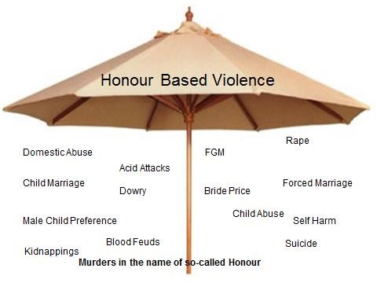
Boys as well as girls can suffer Honour Based Violence, where there are concerns about actual or risk of honour based violence, we will follow the One Chance Rule: you may only have one chance to speak to a potential victim of honour based violence and, therefore, only one chance to save a life.
Where we have concerns relating to Honour Based Violence or abuse, we will follow the LSCP procedures via:
https://liverpoolscb.org.uk/scp/professionals-volunteers/forced-marriage-and-honour-basedviolence

Forced marriage
A forced marriage is a marriage in which one or both spouses do not consent to the marriage but are coerced into it. Duress can include physical, psychological, financial, sexual and emotional pressure. In the cases of some vulnerable adults who lack the capacity to consent, coercion is not required for a marriage to be forced.

Emotional control. Removing from school or education, controlling freedom of movement up to and including house arrest, preventing the victim from learning English, preventing professionals from having any individual contact with the victim, in the case of incoming spouses, threatening to have incoming spouses deported to the country of origin , often these threats will include removal of the victim’s children, control over the victim’s visa status, use of black magic by way of amulets, potions or spells to exert control over the victim.
Physical abuse. This can involve parents and siblings, husbands and in-laws in terms of an extended family and /or community. This includes the spectrum of physical abuse from threats of physical violence, up to and including acid attacks and murder.
Financial abuse. Controlling the income of the victim, many victims will be refused access to any money, even in some cases their own earnings, in order to maintain control and dependency.
Sexual abuse. Where there has been Forced Marriage there is often criminal behaviour such as kidnap and abduction, false imprisonment, administering noxious substances (to ensure compliance) and rape. There have been cases of victims having been drugged as part of an abduction both within the UK and to remove victims from the UK for the purposes of marriage.
Emotional abuse to the victim and to a third party, threats of harm to the victim can include by family members, both here and in the countries of origin, criticism and humiliation of the victim, enforced servitude by way of unpaid work either in family businesses or within the home, sometimes referred to as a form of domestic slavery. This abuse can involve the victim’s children being removed from her care to be cared for by another member of the extended family. Emotional abuse can include threats by the perpetrator to harm themselves (i.e. I will kill myself if you do not marry him or her). They can include shaming in front of the entire community. Lastly, community collusion. A distinct difference between domestic violence and Honour Based Violence is that there is the element of collusion between perpetrators, be they members of the victim’s family or in-laws or extended family and the wider community.
Confidentiality and disclosure Risk can escalate very suddenly. The same level of confidentiality will be applied as to any other safeguarding matter. It should always be remembered that in the case of HBV and FM, perpetrators may go to enormous lengths to obtain information about the whereabouts of a victim in hiding, up to and including hacking into information held in computer databases. In some cases, existing family or professional networks have been used, e.g. Taxi Drivers. MPs and GPs have been asked to divulge information. Special care should be given when considering the use of interpreters and advice should be taken if you are unsure as to who is safe.

Where we have concerns relating to Forced Marriage, we will follow the LSCP procedures via:
https://liverpoolscb.org.uk/scp/professionals-volunteers/forced-marriage-and-honour-basedviolence

Female Genital Mutilation (FGM)

Female Genital Mutilation comprises all procedures involving partial or total removal of the external female genitalia or other injury to the female genital organs. It is illegal in the UK and a form of child abuse with long-lasting harmful consequences. (FGM can come to be seen as a natural and beneficial practice carried out by a loving family, which places barriers in the way of [potential] victims coming forward to raise concerns or talk openly. Equally, staff should note that girls at risk of FGM may not yet be aware of the practice or that it may be conducted on them). UNICEF indicates that 200 million women and girls in 30 countries in Africa and the Middle East have experienced FGM or Cutting. The map below gives an indication as to incidence and prevalence:

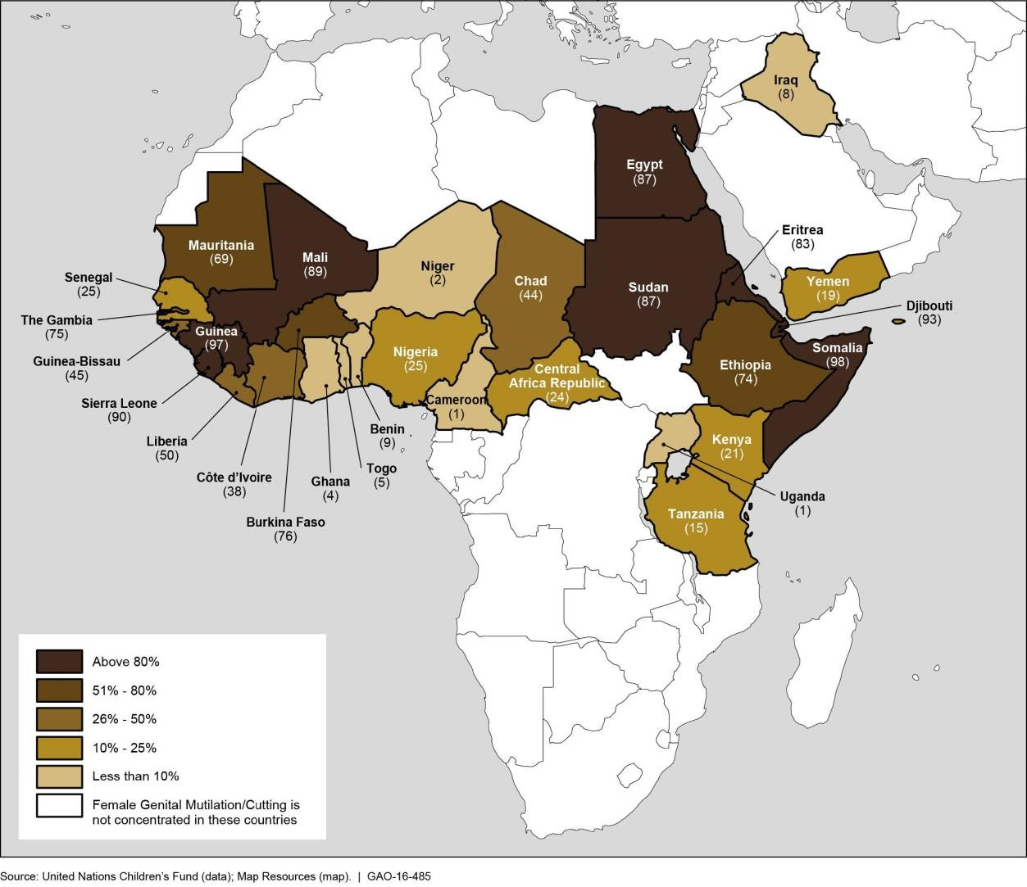

FGM has been documented in Iraq, Israel, Oman, UAE, Occupied Palestinian Territories, India, Indonesia, Malaysia, and Pakistan. It can also happen anywhere in the UK. The age range for FGM is infancy to 15 years of age and occasionally adult women. Predominantly FGM takes places between the ages of 3 and 12 years.

Indicators include:
- Family origins are from a country where it is practiced;
- mother or a sister who has undergone FGM;

- mention of a 'party', 'celebration', 'becoming a woman';
- visiting older relatives visiting from the country of origin;
- being taken on an extended holiday to the country of origin – particularly in the 3 weeks leading up to the school summer holidays.
- talk about a ‘special’ procedure to become a woman

FGM: multi agency practice guidelines: https://www.gov.uk/government/publications/female-genital-mutilation-guidelines
Pages 16 -17 - indicators
Pages 42 - the role of schools and colleges.
Female Genital Mutilation: Guidance for schools June 2019:

http://nationalfgmcentre.org.uk/wp-content/uploads/2019/06/FGM-Schools-Guidance-NationalFGM-Centre.pdf
Where we have concerns relating to Female Genital Mutilation, we will follow the LSCP procedures: https://liverpoolscb.proceduresonline.com/chapters/p_fem_gen_mut.html
As of 31st October 2015, all teachers who discover (either by disclosure by the victim or visual evidence) that FGM appears to have been carried out on a child under the age of 18 will immediately report this themselves to the police. They will consider discussing this with the DSL (unless there is a specific reason not to do so) and involve CSC as appropriate. (Serious Crime Act 2015, statutory duty to report from section 5B of the FGM Act 2003 (s74 as inserted))

Child Sexual Exploitation:
Child sexual exploitation is a form of child sexual abuse. It occurs where an individual or group takes advantage of an imbalance of power to coerce, manipulate or deceive a child or young person under the age of 18 into sexual activity (a) in exchange for something the victim needs or wants, and/or (b) for the financial advantage or increased status of the perpetrator or facilitator. The victim may have been sexually exploited even if the sexual activity appears consensual. Child sexual exploitation does not always involve physical contact; it can also occur through the use of technology.
Via the curriculum, the school staff will raise awareness around positive healthy relationships and where appropriate specifically raise awareness of CSE and the grooming process. Any concerns re CSE will be reported to the DSL who will follow the LSCP Pan Merseyside Multi Agency Child Exploitation protocol1:

https://liverpoolscb.proceduresonline.com/pdfs/pan_merseyside_exploit.pdf

Staff recognise that any child from any walk of life is vulnerable to CSE, for many children they will not recognise that they are a victim and will often be closer to those abusing them than those trying to help them. Staff recognise that children can be abused in the real world and the virtual world. Research tells us that some children are more vulnerable to CSE; these may include children who are looked after and children with learning disabilities. It is also estimated that a third of victims are boys although research tells us that like child sexual abuse, girls are more likely to disclose than boys.
With regard to consent, some children will believe that they are in a loving relationship, no child, no matter what age can give consent to sexual abuse even where a child may believe that they are engaging voluntarily in sexual activity with the person or persons who is exploiting them. It is not only adults who groom and exploit children and that they can be groomed by peers and/or as part of gang related activity.

Potential Indicators of CSE:

Potential indicators of Child Sexual Exploitation
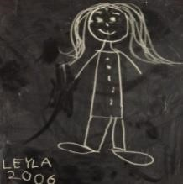
SEXUAL HEALTH & BEHAVIOUR

Sexually transmitted infections; pregnancy, terminations; inappropriate sexualised behaviour(s)
ABSENT FROM SCHOOL OR REPEATEDLY RUNNING AWAY
Truancy or regularly going missing / running away
FAMILIAL ABUSE AND / OR PROBLEMS AT HOME
Familial abuse or neglect; forced marriage or 'honour-based' violence; domestic abuse; substance / alcohol misuse; parental mental ill-health; homelessness / being in temporary accommodation; privately fostered / Looked After

EMOTIONAL AND PHYSICAL CONDITION
Suicidal ideation, self-harm; low self-esteem / confidence; confusion re sexual orientation; learning difficulties / disability; poor mental health; unexplained injuries or changes in appearance
GANGS, OLDER AGE GROUPS, INVOLVED IN CRIMINALITY
Direct involvement with gang members; involvement in criminal activity; involvement with older individuals or lacks same-age friends, contact with victims of CSE
USE OF TECHNOLOGY, SEXUAL BULLYING
Evidence of 'sexting', sexualised communication online; problematic use of internet / social networking; multiple phones, spending more time on phones, being secretive
ALCOHOL OR DRUG MISUSE

Problematic substance use, slurred speech, irritable, difficulty balancing, evidence of drug or alcohol use,
RECEIPT OF UNEXPLAINED GIFTS OR MONEY
Unexplained finances / gifts including mobile phone credit, clothes, jewellery, money
DISTRUST OF AUTHORITY FIGURES
Resistance to communicating with parents, teachers, social workers, foster carers, health professionals, Police et al

Modern Slavery and Human Trafficking
Modern slavery is a form of organised crime in which individuals including children and young people are treated as commodities and exploited for criminal gain. Children are recruited, moved or transported and then exploited, forced to work or sold. The Modern Slavery Act 2015 (applicable mostly in England and Wales) includes two substantive offences i) human trafficking, and ii) slavery, servitude and forced or compulsory labour.
Boys and girls of all ages are affected and can be trafficked into, within ('internal trafficking'), and out of the UK for many reasons and all forms of exploitation - e.g. sex trafficking - children can be groomed and sexually abused before being taken to other towns and cities where the sexual exploitation continues. Victims are forced into sexual acts for money, food or a place to stay. Other forms of slavery involve children who are forced to work, criminally exploited and forced into domestic servitude. Victims have been found in brothels or saunas, farms, in factories, nail bars, car washes, hotels and restaurants and commonly are exploited in cannabis cultivation. Debt bondage (forced to work to pay off debts that realistically they will never be able to), organ harvesting and benefit fraud are other types of modern slavery.
Children and young people may be exploited by parents, carers or family members. Often the child or young person will not realise that family members are involved in the exploitation.
Some young people may not be victims of human trafficking but are still victims of modern slavery. Slavery, servitude and forced or compulsory labour may also be present in trafficking cases; however, not every young person who is exploited through forced labour has been trafficked.
Indicators:
A reluctance to seek help - victims may be wary of the authorities for many reasons such as not knowing who to trust or a fear of deportation or concern regarding their immigration status and may avoid giving details of accommodation or personal details;
- The child seeming like a willing participant in their exploitation, e.g. involvement in lucrative criminal activity - however this does not mean they have benefitted from the proceeds;
- Discrepancies in the information victims have provided due to traffickers forcing them to provide incorrect stories;
- An unwillingness to disclose details of their experience due to being in a situation of dependency;
- Brought or moved from another country;
- An unrelated or new child discovered at an address;
- Unsatisfactory living conditions - may be living in dirty, cramped or overcrowded accommodation;
- Missing - from care, home or school - including a pattern of registration and de-registration from different schools;
- Children may be found in brothels and saunas;
- Spending a lot of time doing household chores;
- May be working in catering, nail bars, caring for children and cleaning;
- Rarely leaving their home, with no freedom of movement and no time for playing;
- Orphaned or living apart from their family, often in unregulated private foster care;
- Limited English or knowledge of their local area in which they live;
- False documentation, no passport or identification documents;
- Few or no personal effects - few personal possessions and tend to wear the same clothing;
- No evidence of parental permission for the child to travel to the UK or stay with the adult;
- Little or no evidence of any pre-existing relationship with the adult or even an absence of any knowledge of the accompanying adult; • Significantly older partner;
- Underage marriage.
Physical Appearance - Victims may show signs of physical or psychological abuse, look malnourished or unkempt, or appear withdrawn. Physical illnesses - including work-related injuries through poor health and safety measures, or injuries apparently as a result of assault or controlling measures. There may be physical indications of working (e.g. overly tired in school or indications of manual labour).
Sexual health indicators - sexually transmitted infections, or pregnancy; injuries of a sexual nature and /or gynaecological symptoms.
Psychological indicators - suffering from post-traumatic stress disorder which may include symptoms of hostility, aggression and difficulty with recalling episodes and concentrating.
Depression/self-harm and/or suicidal feelings; an attitude of self-blame, shame and extensive loss of control; drug and or/alcohol use.
Where we have concerns relating to Modern Slavery we will follow the LSCP procedures: https://liverpoolscb.proceduresonline.com/chapters/p_safeg_ch_ab.html
The DSL will also complete the Child National Referral Mechanism form available via https://www.gov.uk/government/publications/human-trafficking-victims-referral-and-assessmentforms

Serious Violence
At Cavendish View School, all staff are aware of the indicators that my signal that children are at risk from, or are involved in serious violent crime. These may include children involved on or affected by gang and youth violence or involved in Criminal Exploitation (County Lines) as detailed;

Children Affected by Gangs and Youth Violence
Defining a gang is difficult. They tend to fall into three categories: peer groups, street gangs and organised crime groups. It can be common for groups of children and young people to gather in public places to socialise, and although some peer group gatherings can lead to increased antisocial behaviour and low-level youth offending, these activities should not be confused with the serious violence of a street gang.
A street gang can be described as a relatively durable, predominantly street-based group of children who see themselves (and are seen by others) as a discernible group for whom crime and violence is integral to the group's identity.
A street gang will engage in criminal activity and violence and may lay claim over territory (not necessarily geographical for example it could include an illegal economy territory).They have some form of identifying structure featuring a hierarchy usually based on age, physical strength, propensity to violence or older sibling rank. There may be certain rites involving antisocial or criminal behaviour or sex acts in order to become part of the gang. They are in conflict with other similar gangs.
There is a distinction between organised crime groups and street gangs based on the level of criminality, organisation, planning and control. However, there are significant links between different levels of gangs for example street gangs can be involved in drug dealing on behalf of organised criminal groups Young men and women may be at risk of sexual exploitation in these groups.
Children may be involved in more than one 'gang', with some cross-border movement, and may not stay in a 'gang' for significant periods of time. Children rarely use the term 'gang', instead they used terms such as 'family', 'breddrin', 'crews', 'cuz' (cousins), 'my boys' or simply 'the people I grew up with'.
Risks
The risk or potential risk of harm to the child may be as a victim, a gang member or both - in relation to their peers or to a gang-involved adult in their household. Teenagers can be particularly vulnerable to recruitment into gangs and involvement in gang violence. This vulnerability may be exacerbated by risk factors in an individual’s background, including violence in the family, involvement of siblings in gangs, poor educational attainment, or poverty or mental health problems.
A child who is affected by gang activity, criminal exploitation or serious youth violence can be at risk of significant harm through physical, sexual and emotional abuse. Girls may be particularly at risk of sexual exploitation.
Violence is a way for gang members to gain recognition and respect by asserting their power and authority in the street, with a large proportion of street crime perpetrated against members of other gangs or the relatives of gang members.
The specific risks for males and females may be quite different. There is a higher risk of sexual abuse for females and they are more likely to have been coerced into involvement with a gang through peer pressure than their male counterparts.
There is evidence of a high incidence of rape of girls who are involved with gangs. Some senior gang members pass their girlfriends around to lower ranking members and sometimes to the whole group at the same time. Very few rapes by gang members are reported.
Gang members often groom girls at school using drugs and alcohol, which act as disinhibitors and also create dependency, and encourage / coerce them to recruit other girls through school / social networks.
Indicators
- Child withdrawn from family;
- Sudden loss of interest in school or change in behaviour. Decline in attendance or academic achievement (although it should be noted that some gang members will maintain a good attendance record to avoid coming to notice);
- Being emotionally ‘switched off’, but also containing frustration / rage;
- Starting to use new or unknown slang words;
- Holding unexplained money or possessions;
- Staying out unusually late without reason, or breaking parental rules consistently;
- Sudden change in appearance – dressing in a particular style or ‘uniform’ similar to that of other young people they hang around with, including a particular colour;
- Dropping out of positive activities;
- New nickname;
- Unexplained physical injuries, and/or refusal to seek / receive medical treatment for injuries;
- Graffiti style ‘tags’ on possessions, school books, walls;
- Constantly talking about another young person who seems to have a lot of influence over them;
- Breaking off with old friends and hanging around with one group of people;
- Associating with known or suspected gang members, closeness to siblings or adults in the family who are gang members;
- Starting to adopt certain codes of group behaviour e.g. ways of talking and hand signs;
- Going missing;
- Being found by Police in towns or cities many miles from their home;
- Expressing aggressive or intimidating views towards other groups of young people, some of whom may have been friends in the past;
- Being scared when entering certain areas; and
- Concerned by the presence of unknown youths in their neighbourhoods.
Dependant on how the young person communicates to you that they are in a gang, will influence your response. Such a statement may be their declaration of allegiance to their chosen gang or conversely, it may be a cry for help, asking for you to acknowledge their problem and for you to support them to get away from the gang
An important feature of gang involvement is that, the more heavily a child is involved with a gang, the less likely they are to talk about it.
There are links between gang-involvement, criminal exploitation and young people going missing from home or care. Some of the factors which can draw gang-involved young people away from home or care into going missing are linked to their involvement in carrying out drugs along county lines. There may be gang-associated child sexual exploitation and relationships which can be strong pull factors for girls who go missing.
Where we have concerns relating to Gang involvement or youth violence we will follow the LSCP procedures: https://liverpoolscb.proceduresonline.com/chapters/p_gangs.html

Criminal Exploitation (County Lines)
‘County lines’ is the police term for urban gangs supplying drugs to suburban areas and market and coastal towns using dedicated mobile phone lines or ‘deal lines’. It involves child criminal exploitation (CCE) as gangs use children and vulnerable people to move drugs and money. Gangs establish a base in the market location, typically by taking over the homes of local vulnerable adults by force or coercion in a practice referred to as ‘cuckooing’.
County lines is a major, cross-cutting issue involving drugs, violence, gangs, safeguarding, criminal and sexual exploitation, modern slavery, and missing persons
A typical county lines scenario is defined by the following components:
- A group (not necessarily affiliated as a gang) establishes a network between an urban hub and county location, into which drugs (primarily heroin and crack cocaine) are supplied.
- A branded mobile phone line is established in the market, to which orders are placed by introduced customers. The line will commonly (but not exclusively) be controlled by a third party, remote from the market.
- The group exploits young or vulnerable persons, to achieve the storage and/or supply of drugs, movement of cash proceeds and to secure the use of dwellings (commonly referred to as cuckooing).
- The group or individuals exploited by them regularly travel between the urban hub and the county market, to replenish stock and deliver cash.
- The group is inclined to use intimidation, violence and weapons, including knives, corrosives and firearms.
Some indicators of county lines involvement and exploitation are listed below, with those at the top of particular concern:
- Persistently going missing from school or home and / or being found out-of-area;
- Unexplained acquisition of money, clothes, or mobile phones;
- Excessive receipt of texts / phone calls;
- Relationships with controlling / older individuals or groups;
- Leaving home / care without explanation;
- Suspicion of physical assault / unexplained injuries;
- Parental concerns;
- Carrying weapons;
- Significant decline in school results / performance;
- Gang association or isolation from peers or social networks;
- Self-harm or significant changes in emotional well-being.
Where we have concerns regarding county lines we will follow, the LSCP procedures: https://liverpoolscb.org.uk/scp/professionals-volunteers/child-criminal-exploitation
PAN Merseyside Multi-Agency Protocol tackles Child Exploitation across Merseyside through MultiAgency Child Exploitation (MACE) meetings which work to reduce the harm posed to children from
Child Exploitation (this term encompasses both criminal and sexual exploitation) https://liverpoolscb.proceduresonline.com/pdfs/pan_merseyside_exploit.pdf
The DSL will also complete the Child National Referral Mechanism form available via https://www.gov.uk/government/publications/human-trafficking-victims-referral-and-assessmentforms where a child has been trafficked for the purposes of transporting drugs

Peer on Peer Abuse
At Cavendish View School, we recognise that children are capable of abusing their peers. Any incidents of alleged or suspected abuse by children or young people will be taken seriously and reported to the DSL immediately. Staff must also be alert to the possibility that a child or young person who has harmed another may also be a victim and, as such, they may have significant unmet needs themselves. Peer abuse might take various forms; for example (and the following list is not exhaustive):

- Sexual bullying;
- Racial, homophobic, gender or culture-related bullying or abuse;
- Via the use of ICT e.g. sexting, 'revenge pornography' - staff should be particularly mindful of the potential for the misuse of information technology for bullying and abusive purposes;
- Grooming by peers as part of child sexual exploitation;
- Abuse linked to gang-related activity;
- Sexual violence;
- Sexual harassment;
- Upskirting

We know that peer abuse might manifest differently for boys and girls e.g. girls being touched inappropriately or coerced into sexual activity, boys being initiated into gangs etc. Such abuse may also be indicative of a previous or ongoing abusive experience for a perpetrator and / or victim and research indicates that children with SEN, additional or complex needs are particularly vulnerable.

Staff should be mindful of the added vulnerability of children and young people who have been the victims of violent crime, including the risk that they may respond to this by abusing younger or weaker children. The alleged perpetrator is likely to have considerable unmet needs, as well as posing a significant risk of harm to other children. Evidence suggests that such children may have suffered considerable disruption in their lives, may have witnessed or been subjected to physical or sexual abuse, may have problems in their educational development and may have committed other offences. They may, therefore, be suffering, or at risk of suffering, significant harm and be in need of protection. Consequently, any plan to reduce and / or manage risk posed by a child who is alleged to have abused another must also address their needs and [multi-agency] responses should not be about criminalising children unnecessarily.

We recognise that it is not enough 'just' to respond to incidents should they arise. Therefore, we will minimise the possibility of peer abuse by:

- Creating and maintaining an environment which is safe, caring, respectful and stimulating, and which seeks to promote the social, physical and moral development of our pupils;
- Ensuring that core safeguarding and child protection policies and procedures link to, are understood and implemented in conjunction with other, related policies and procedures e.g. IT use and Online Safety, Anti-bullying strategy, Positive Behaviour Support.
- Actively discouraging and challenging all unacceptable behaviour, including all forms of bullying and abuse. We will also challenge the attitudes and behaviours which underpin it;
- Having in place clear strategies for promoting positive behaviour, including a system of rewards and sanctions that is clear to staff, pupils and parents / carers alike;
- Maximising opportunities within the curriculum, via PSHE, assemblies and focused weeks to deliver key keeping safe and associated behavioural, spiritual, moral, social and cultural messages - including the use of external resources and expertise e.g. ; the NSPCC's 'Pants / Underwear Rule' guidance and drawing upon the expertise of external speakers and groups;
- Striking appropriate balances between pupil's right to privacy and the need for proportionate supervision to keep them safe in and around school;
- Ensuring that all adults associated with our school understand their role and responsibilities as role models;
- Ensuring that staff and any volunteers are trained to look for and respond appropriately to any potential indicators of peer abuse;
- Seeking appropriate and timely advice where uncertainty exists and / or concerns arise i.e. from Children's Social Care;
- Ensuring that children, and parents, know how to raise any worries or concerns with adults / staff in school and by signposting them to appropriate sources of advice and support outside school.

Sexual violence and sexual harassment between children in school
At Cavendish View school we recognise that sexual violence and sexual harassment can occur between two children of any sex. That it can also occur through a group of children sexually assaulting or sexually harassing a single child or group of children. Sexual violence and harassment can occur online and off line, can be both physical and verbal, and is never acceptable.
In our school:
- sexual violence and sexual harassment is not acceptable, will never be tolerated and is not an inevitable part of growing up;
- we will take concerns seriously and not dismiss sexual violence or sexual harassment as “banter”, “part of growing up”, “just having a laugh” or “boys being boys”;
- we will challenge behaviour (potentially criminal in nature), such as grabbing bottoms, breasts and genitalia and flicking bras and lifting up skirts and recognise that dismissing or tolerating such behaviours risks normalising them; and
- we recognise that all of the above can be driven by wider societal factors beyond the school and college, such as everyday sexist stereotypes and everyday sexist language.

In line with the Sexual Offences Act 2003, Sexual violence is;
Rape: A person (A) commits an offence of rape if: he intentionally penetrates the vagina, anus or mouth of another person (B) with his penis, B does not consent to the penetration and A does not reasonably believe that B consents.
Assault by Penetration: A person (A) commits an offence if: s/he intentionally penetrates the vagina or anus of another person (B) with a part of her/his body or anything else, the penetration is sexual, B does not consent to the penetration and A does not reasonably believe that B consents.
Sexual Assault: A person (A) commits an offence of sexual assault if: s/he intentionally touches another person (B), the touching is sexual, B does not consent to the touching and A does not reasonably believe that B consents
Sexual Harassment is unwanted sexual conduct of a sexual nature and can occur on or off line. In the context of this policy, it is child on child sexual harassment.
Sexual harassment is likely to: violate a child’s dignity, and/or make them feel intimidated, degraded or humiliated and/or create a hostile, offensive or sexualised environment. Sexual harassment can include the list in not exhaustive: Offline behaviour
- sexual comments, such as: telling sexual stories, making lewd comments, making sexual remarks about clothes and appearance and calling someone sexualised names;
- sexual “jokes” or taunting; physical behaviour, such as: deliberately brushing against someone, interfering with someone’s clothes (The DSL will consider when any of this crosses a line into sexual violence – and experience of the victim will be taken in account when considering this) and displaying pictures, photos or drawings of a sexual nature;
Online behaviour
This may be standalone, or part of a wider pattern of sexual harassment and/or sexual violence.
It may include:
  - non-consensual sharing of sexual images and videos;
  - sexualised online bullying;
  - unwanted sexual comments and messages, including, on social media; and
  - sexual exploitation; coercion and threats.
Harmful Sexual Behaviour
Children’s sexual behaviour exists on a wide continuum, from normal and developmentally expected to inappropriate, problematic, abusive and violent. Problematic, abusive and violent sexual behaviour is developmentally inappropriate and may cause developmental damage
When considering harmful sexual behaviour, ages and the stages of development of the children are critical factors to consider. Sexual behaviour between children can be considered harmful if one of the children is much older, particularly if there is more than two years’ difference or if one of the children is pre-pubescent and the other is not. However, a younger child can abuse an older child, particularly if they have power over them, for example, if the older child is disabled or smaller in stature.
Further information is available via the NSPCC; https://www.nspcc.org.uk/preventingabuse/child-abuse-and-neglect/harmful-sexual-behaviour/

Responding to Allegations of Peer Abuse Inc. sexual violence and sexual harassment between children in school
Everyone in school recognises the need for sensitivity and proportionality when dealing with these difficult issues. The following rules of thumb will apply to their management:

- The wishes of the victim in terms of how they want to proceed;

- The DSL will seek appropriate and timely advice wherever necessary and follow the LSCP procedures. The safety and best interests of victim(s) will be the paramount consideration at all times. The DSL will also consider the possibility and take account of any wider and / or ongoing risk(s) to others;
- The needs of the victim and the needs of the alleged perpetrator will be considered separately;
- In addition to safeguarding the identified victim, the school and other agencies should consider (i) whether the alleged perpetrator seems to pose a risk to any other children; and (ii) how best to manage that risk;
- Children and young people who abuse others are responsible for their abusive behaviour, and safeguarding action must include addressing their behaviour and its causes;
- The alleged perpetrator is likely to have considerable unmet needs as well as posing a significant risk of harm to other children;
- Where necessary, the school will participate fully in a co-ordinated approach by Children’s Social Care, youth offending, education and health agencies;
- Where the concerns are of a sexual nature, the DSL will need to consider completing a Risk Management Plan;
- Where it is considered that there is a need for an in house Risk Management Meeting, and if needed to speak to the Safeguarding Coordinator regarding this.
Where we have concerns relating to peer on peer, we will follow the LSCP procedures http://liverpoolscb.proceduresonline.com/chapters/p_ch_abuse.html

The school will also work within the Sexual Harassment and Sexual Violence advice;
https://assets.publishing.service.gov.uk/government/uploads/system/uploads/attachment_data/file /707653/Sexual_Harassment_and_Sexual_Violence_Advice.pdf

Further information is also available at:
https://www.brook.org.uk/our-work/category/sexual-behaviours-traffic-light-tool

Bullying including Online Bullying or Cyberbullying
While bullying between children is not a separate category of abuse and neglect, it is a very serious issue that can cause anxiety and distress. All incidences of bullying, including cyber-bullying and prejudice-based bullying should be reported and will be managed through our tackling-bullying procedures. Cyberbullying is the use of mobile phones; instant messaging, e-mail, chat rooms or social networking sites such as Facebook and Twitter to harass threaten or intimidate someone. One of the issues with cyberbullying is the increasingly early access to these technologies.
Examples are:
- Encouraging a child to self-harm or end their own life;
- Setting up false accounts and posting within that on line account;
- Trolling – the sending of messages that are upsetting or menacing via social media;
- Hacking accounts in order to embarrass the child or cause trouble for them;
- Encouraging voting in an abusive pole;
- Racism, sexism or homophobia;
- Setting up hate sites or groups in relation to a particular child;
- Sexting.
Where we have concerns we will follow the LSCP procedures relating to bullying: https://liverpoolscb.proceduresonline.com/chapters/p_bullying.html
Information for parents is available via: https://liverpoolscb.org.uk/scp/parents-carers/bullying-1

Self-Harm and Suicide
Any concerns regarding self-harm or suicidal intent should be considered under the LSCP procures. Some children in ‘acute need’ may require Child in Need Section 17 support. This could include children who self-harm or disclose an intent to commit suicide. Broadly defined, self-harm refers to the deliberate attempt to physically injure oneself without causing death. This can include self-mutilation (e.g. cutting behaviours), self-poisoning, burning, scalding, banging, and hair pulling.
Although clearly damaging, alcohol and drugs misuse, eating disorders, unsafe sex and other excessively risky behaviour, such as dangerous driving, are not generally classified as self-harm and would be classed as risk taking behaviours.
If a child is suspected or found to be self-harming, the strategies that should be taken are those determined by any existing plan, for example, in the child's Placement Plan. If no plan or strategy exists, all reasonable measures should be taken to reduce or prevent continuation of the behaviour. In all cases, consideration will be given to the DSL undertaking a Risk Management Plan and advice sort in relation to this. This may include providing additional supervision, minimising access to materials that may be used to self-harm or, as a last resort, use of Physical Intervention, advice to the parent /carer regarding a GP appointment with a view to a CAMHS referral or where there is an immediate threat to life, calling for assistance from the emergency services.
Where we have concerns relating to the suicide and self-harm we will follow the LSCP procedures: https://liverpoolscb.proceduresonline.com/chapters/p_ch_self_harm.html . This link will provide guidance on how to support children/young people who have thoughts of, or have self-harmed and the procedures that need to be followed.

Domestic Abuse
The Government definition of domestic abuse is:
Any incident or pattern of incidents of controlling, coercive, threatening behaviour, violence or abuse between those aged 16 or over who are, or have been, intimate partners or family members regardless of gender or sexuality. The abuse can encompass, but is not limited to:
- psychological
- physical
- sexual
- financial
- emotional

Controlling behaviour
Controlling behaviour is a range of acts designed to make a person subordinate and/or dependent by isolating them from sources of support, exploiting their resources and capacities for personal gain, depriving them of the means needed for independence, resistance and escape and regulating their everyday behaviour.
Coercive behaviour
Coercive behaviour is an act or a pattern of acts of assault, threats, humiliation and intimidation or other abuse that is used to harm, punish, or frighten their victim
Where there are concerns that any young person is a witness to domestic abuse or is a perpetrator, then we will follow the LSCP procedures: https://liverpoolscb.proceduresonline.com/chapters/p_dom_abuse.html
This link provides a definition of Domestic Abuse, the impact on children and young people, what action is required to take to safeguard and the current legislation relating to Domestic Abuse.
Further information is available via:
NSPCC: UK domestic-abuse signs symptoms effects
Refuge: what is domestic violence/effects of domestic violence on children Safelives

Homelessness
Being homeless or being at risk of being homeless presents a real risk to a child’s welfare. This can be a child or their family being made or being at risk of homelessness or a young person who aged 16 or 17 living independently from their parents or guardians.
Indicators can be:
- Household debt;
- Rent arrears
- Domestic abuse
- A family being asked to leave a property
- Anti-social behaviour
Where there are concerns about homelessness or the risk of it, the DSL will be aware of make referrals to the Local Housing Authority at the earliest opportunity. Where a child has been harmed or is at risk of significant harm, a referral will also be made to Children’s Social Care.

Radicalisation and Extremism
The government definition of radicalisation is:
Radicalisation is defined as - "the process by which people come to support terrorism and extremism and, in some cases, to then participate in terrorist activity".
Extremism is defined as - "vocal or active opposition to fundamental British values including democracy, the rule of law, individual liberty and mutual respect and tolerance of different faiths and beliefs". The government also includes in its definition calls for the death of members of the armed forces
Prevent is the name given to the Government's strategy to respond to the challenge of extremism; it is part of its broader counter terrorism strategy which is known as Contest. We recognise that Prevent is an integral part of safeguarding in school that it is not separate and does not stand alone. For example, we will be mindful of its potential significance in respect of:

- Recruitment and selection;
- The use of external providers and speakers;
- Online safety;
- The curriculum and our duty to promote and support children's spiritual, moral, social and cultural development

Radicalisation refers to the process by which a person comes to support terrorism and forms of extremism. There is no single way of identifying an individual who is likely to be susceptible to an extremist ideology. It can happen in many different ways and settings. Specific background factors may contribute to vulnerability which are often combined with specific influences such as family, friends or online, and with specific needs for which an extremist or terrorist group may appear to provide an answer. The internet and the use of social media in particular has become a major factor in the radicalisation of young people.

Staff will be alert to changes in children’s behaviour which could indicate that they may be in need of help or protection. School staff will use their professional judgement in identifying children who might be at risk of radicalisation and act proportionately following the LSCP procedures:
https://liverpoolscb.proceduresonline.com/chapters/p_sg_ch_extremism.html

This will include making referrals to the Channel programme as appropriate. Prevent Duty Guidance: (Paragraphs 57-76 covers schools) https://www.gov.uk/government/publications/prevent-duty-guidance Further information is available via the website Educate against hate https://educateagainsthate.com

The Counter Terrorism and Security Act 2015 places a duty on a number of organisations, including schools, to prevent all radicalisation and extremism. The purpose is to protect children from harm and to ensure that they are taught in a way that is consistent with the law and British values.
In order to comply with the Prevent Duty:

- We have assessed the risk of pupils being drawn into radicalization and have developed a prevent action plan to reduce this risk and this has been signed-off by proprietary board;
- We will always conduct relevant checks in order to prohibit extremist speakers and events in school;
- We have put strategies in place to manage access to extremist material.

Our Single point of Contact in School (SPOC):
Lyndsey Murphy

Prevent/Channel:
Moner Ahmed (Prevent Coordinator) 0151-233-7018 moner.ahmed@liverpool.gov.uk
Joanna Fitzsimmons (Education Officer) 0151233 7018 joanna.fitzsimmons@liverpool.gov.uk
Alison Burnett (Channel Coordinator) 0151 233 7018 alison.burnett@liverpool.gov.uk

Channel Referrals: https://liverpoolscb.proceduresonline.com/pdfs/app_1_channel_ref.pdf ADVICE:
Det Sgt Paul Storey (Channel Police Practitioner) 0151-777-8328
Det Sgt Darren Taylor 0151-777-8311
MSOC.Special.Branch@Merseyside.pnn.police.uk

Sexting
The UK Council for Child Internet Safety in their guidance: Sexting in schools and colleges, states that there is no clear definition of sexting and state:
Many professionals consider sexting to be ‘sending or posting sexually suggestive images, including nude or semi-nude photographs, via mobiles or over the Internet.’ Yet when young people are asked ‘What does sexting mean to you?’, they are more likely to interpret sexting as ‘writing and sharing explicit messages with people they know’. Similarly, many parents think of sexting as flirty or sexual text messages rather than images.
Where our school has concerns about sexting, we will follow the UK Council for Child Internet Safety (UKCCIS) sexting in schools and colleges guidance which is available via: https://assets.publishing.service.gov.uk/government/uploads/system/uploads/attachment_data/file /609874/6_2939_SP_NCA_Sexting_In_Schools_FINAL_Update_Jan17.pdf
There are also resources available via the South West Grid for Learning:
http://swgfl.org.uk/
All concerns re sexting must be reported to the DSL immediately who will assess the situation on a case by case basis and on its merits. It may be necessary to assist the child/parents in reporting it and/or removing the image from a website or elsewhere.
Help and advice is available via the Professionals Online Safety Helpline (Monday to Friday 10am to 4pm)
Email: helpline@saferinternet.org.uk
Telephone: 0344 381 4772 ing with Sexting and Related Issues - a quick guide
Always | Never
General
Inform the DSL immediately, record the incident, and act in accordance with school online safety and child protection policies and procedures | View, download or share the imagery yourself (if you have seen it as the child presented it to you – inform your DSL)
Explain to the young person that you need to report it and reassure them that they will receive help and support from the DSL | Ask the child to share or download
Confiscate and secure the device(s). Turn the device off and give it to the DSL who will place under lock and key until handed to the police. | View the image, send, share or save the image anywhere, allow pupils to do any of the above
Image has been shared across a school network, a website or a social network:
Block the network to all users and isolate the image | Send or print the image, move the material from one place to another.

The DSL role in searching devices, viewing and deleting imagery
The Education Act 2011 gives schools and/or teachers the power to seize and search an electronic device if they think there is good reason to do so i.e. if there is reason to believe it contains indecent images or extreme pornography. However, staff should exercise caution and bear the following in mind before searching a device:

- The action must be in accordance with the school’s child protection policy, related policies and procedures e.g. ICT / Online safety, anti-bullying, positive behaviour
- Any search should only be conducted following authorisation by the Principal

Imagery will only be viewed by the DSL when it;

- is the only way to make a decision about whether to involve other agencies (i.e. it is not possible to establish the facts from the young people involved)
- is necessary to report the image to a website, app or suitable reporting agency to have it taken down, or to support the young person or parent in making a report
- is unavoidable because a pupil has presented an image directly to the DSL or the imagery has been found on a school device or network

If it is necessary to view the imagery then the DSL will:
- Never copy, print or share the imagery; this is illegal.
- Discuss the decision with the Principal.
- Ensure viewing is undertaken by the DSL or another member of the safeguarding team with delegated authority from the Principal.
- Ensure viewing takes place with another member of staff present in the room, ideally the Principal or a member of the senior leadership team. This staff member does not need to view the images.
- Wherever possible ensure viewing takes place on school premises, ideally in the Principal or a member of the senior leadership team’s office.
- Ensure wherever possible that a staff member of the same sex as the young person in the imagery views images.
- Record the viewing of the imagery within the concern/referral section of the Ambito Care and Education C360 database, including who was present, why the image was viewed and any subsequent actions Ensure this is signed and dated and meets the wider standards set out by Ofsted for recording safeguarding incidents.

Deleting Imagery
If the DSL decides that other agencies do not need to be involved, then consideration will be given to deleting the image from the device[s] to limit any further sharing of images. The DSL will record this action with a clear rationale as to why this action was taken. This will be within the concern/referral section of the Ambito Care and Education C360 database,

Children Missing Education
At Cavendish View School, we recognise that children going missing, particularly repeatedly, can act as a vital warning sign of a range of safeguarding possibilities. This may include abuse and neglect, which may include sexual abuse or exploitation and child criminal exploitation. It may indicate mental health problems, risk of substance misuse, risk of travelling to conflict zones, risk of female genital mutilation or risk of forced marriage.
In our school, we have an emergency contact list with at least 2 named people on it. On an annual basis ready for the new school year, we update that contact list by sending out the data request pro forma to parents and carers.
In line with the duty under section 10 of the Children Act 2004, the school will follow up any unauthorised absence. The initial enquiry will be by 10 am on the first day of non-attendance where there has been no contact from the parent or carer to explain the reason for the absence.
- Where it has not been possible to make contact, the other numbers on the contact list will be tried.
- Where no contact has been made by day 2, the school will conduct an unannounced home visit on day 2.
- Where no contact is made, the person undertaking the home visit will make enquiries of neighbours.
- Further checks including checking with any other known relatives, landlords – private or social housing providers – and other local stakeholders who are involved. This will be both via phone and via home visits.
- Where a child has been absent and no contact made by day 2, the matter will be recorded on the Ambito Care and Education Safeguarding database as a concern and within the chronology of contacts all contact with relatives, neighbours, landlords and other local stakeholders will be recorded in the chronology of contacts.
- If there is reason to believe a child is in immediate danger or at risk of harm, a referral will be made to children’s social care (and the police if appropriate) and be raised as a referral on the Ambito Care and Education safeguarding database.

Our school will follow the relevant Local Authority agreement for reporting for children who fail to attend without the schools permission for a period of 10 days or more or who regularly fail to attend.

A young carer is a child under 18 years who helps to look after a relative who has a condition such as a disability, mental health issue, substance misuse problem or illness. In the majority of cases young carers will care for someone in their immediate family e.g. a parent or sibling.
Care responsibilities can include:
- Washing, dressing or other intimate care
- Personal Inc. giving medication, changing dressings etc.
- Feeding
- Household chores
- Child care responsibilities

Under the Children and Families Act 2014, the rights of young carers was significantly strengthened and all young carers have the right to an assessment regardless of who they care for, how often and when. An assessment can also be undertaken without a request on the ‘appearance of need’ basis.
Local Authorities must:

- Must take a whole family approach to assessing and supporting adults so that young carer’s needs are identified when undertaking an adult or adult carer's needs assessment;
- Ensure that adult and children’s social care services work together to ensure effective assessment.
http://liverpoolscb.proceduresonline.com/chapters/p_young_carers.html Further resources are available at:
https://www.carersuk.org/help-and-advice/practical-support/getting-care-and-support/youngcarers-and-carers-of-children-under-
18?gclid=EAIaIQobChMI84ig6aS35AIVBLTtCh2I5QheEAAYAyAAEgK9xvD_BwE

Part Five: Children Looked After & those with SEN/additional needs

Children Looked After (LAC/CLA)
Children who have suffered adversity via abuse and neglect can end up being looked after by the Local Authority. The school ensures that staff have the necessary skills and understanding to keep looked after children safe. Appropriate staff have information about a child’s looked after legal status and care arrangements, including the level of authority delegated to the carer by the authority looking after the child. Staff also have the knowledge and skills to keep previously Looked After Children safe.
The Designated Safeguarding Lead must be aware of the child’s:
- Legal status;
- The name of the Virtual Principal;
- Contact arrangements and any restrictions around contact;
- Whom is allowed to have information beyond educational achievement information;
- Manage sensitive/confidential information in line with the children best interests, wishes and feelings;
- Where children are care leavers, the DSL will have details of the LA personal advisor and liaise with them as necessary.
The Designated Teacher is responsible for:
- Promoting education achievement of children who are looked after;
- Ensuring that records and plans in respect of children who are looked after are generated, maintained, updated and effective in line with nations requirements and local protocols e.g. PEPs;
- Providing appropriate information to the DSL;
- Managing sensitive/confidential information in line with the children best interests, wishes and feelings.
In our school the Designated Teacher is Bethen Donnelly
In addition to responsibilities for LAC, this teacher will also be responsible for promoting the educational achievement of children who have left care through adoption, special guardianship or child arrangement orders or who were adopted from state care outside England and Wales.

Private Fostering
Private fostering is when a child under the age of 16 (under 18 if disabled) is cared for by someone who is not their parent or a 'close relative‘ for a period of 28 days or more.
The Local Authority must be notified. This will result in an assessment, support and guidance.
If a private fostering arrangement is brought to school’s attention, then the DSL must be informed. The DSL then has a duty to inform Children’s Social Care.
The following link provides a definition of Private Fostering and lists the obligations of a private foster carer and the duties of the Local Authority once notified of a private fostering arrangement and the LA’s role during the arrangement.
https://liverpoolscb.org.uk/scp/professionals-volunteers/private-fostering

Where we become aware of a private fostering arrangement, we will follow the LSCP procedures:
https://liverpoolchildcare.proceduresonline.com/chapters/p_private_fost.html
Children with Special Educational Needs and Disabilities
Children with special education needs (SEN) and disabilities can face additional safeguarding challenges. Research tells us that they are three times as likely to be abused as a child without a disability is. In our school, we recognise that additional barriers can exist when identifying abuse and neglect for this group of children. In our school we always consider the possibility of abuse particularly relating to this group of children and do not automatically assume that behaviour, mood or injury relate to the child’s disability. We recognise that children with SEN and disabilities can be disproportionately impacted by such issues as bullying without showing any outward signs. We also recognise that as with all children, it is not just the overt signs of abuse that will be looked for, but will be mindful at all times of the possibility of more subtle signs that may indicate a wider range of safeguarding issues such as emotional abuse due to ridicule, financial abuse, Fabricated or Induced
Illness (FII),
Our staff work hard to give all children opportunities and a voice, our pastoral team is available to support a child at any time.
Our staff will always consider:
- What do I know about this child;
- What are their developmental age and level of understanding;
- How does their additional needs impact on their development;
- How do I need to adapt my communication to meet the needs of the child;
Our DSL and SENCO will liaise on a regular basis and as soon as there are any safeguarding issues identified. The DSL will make decisions in line with Local thresholds guidance as to what action is taken. The SENCO is Bethen Donnelly

Part Six: A Safer School

rt Six: A Safer School

Safer Recruitment
Our school complies with Part Three of Keeping Children Safe in Education 2020 & September 2021 update; Proprietary Board will take steps to prevent people who pose a risk of harm from working with children by adhering to statutory responsibilities to check staff who work with children, by carrying out the required checks and verifying the applicant’s identity, qualifications and work history. The school will take proportionate decisions on whether to ask for any checks beyond what is required; and ensuring volunteers are appropriately supervised. The school has a written recruitment and selection policies and procedures in place.

- The school obtains written confirmation from supply agencies or third party organisations that agency staff or other individuals who may work in the school have been appropriately checked.

- The school maintains a single central record of recruitment checks undertaken.

- In our school, at least one person on any appointment panel has undertaken safer recruitment training.

Updated January 2021
From 01 January 2021 the TRA Teacher Services system will no longer maintain a list of those teachers who have been sanctioned in EEA member states. Advice about how information about a teacher’s past conduct may be obtained can be found at paragraph 172.
Schools and colleges must make any further checks they think appropriate so that any relevant events that occurred outside the UK can be considered. These checks could include, where available:

- Criminal records checks for overseas applicants – Home Office guidance can be found on GOV.UK; and for teaching positions

- Obtaining a letter of professional standing from the professional regulating authority in the country in which the applicant has worked. Advice about which regulatory or professional bod applicants should contact is available from the National Recognition Information Centre for the United Kingdom, UK NARIC.

Staff Training and Induction
It is important that all staff receive training to enable them to recognise the possible signs of abuse, neglect and exploitation and to know what to do if they have a concern.

New staff will receive the Ambito Care and Education safeguarding briefing delivered by the DSL or one of the deputy DSLs on day 1. This includes the school’s child protection policy, staff code of conduct, the positive behaviour support policy, the safeguarding arrangements for children who go missing from education, reporting and recording arrangements, the guidance for Safer Working Practice for those who work in Education settings 2019 and identity of the DSL and any deputies.

Supply staff and volunteers, will be told who the DSL and any deputies are, given a copy of the pocket guide to safeguarding and be will informed of the reporting and recording process in school, they will be given a copy of the yellow reporting concerns to the DSL pro forma as well as the policies listed above that are given the Ambito Care and Education staff.

All staff, including the Principal will receive training that is regularly updated; this includes annual refresher training, safeguarding and child protection updates via email, e-bulletins and staff meetings throughout the year.

The DSL and any deputies will update their knowledge and skills on an annual basis via attending meetings with other DSL’s (DSL forum), reading or undertaking additional training, this is in addition to the Ambito Care and Education required e-learning and their 2 year DSL refresher training.

Whistle blowing if you have concerns about a colleague
Staff who are concerned about the conduct of a colleague towards a child or young person are undoubtedly placed in a very difficult situation. They may worry that they have misunderstood the situation and they will wonder whether a report could jeopardise their colleague’s career. All staff must remember that the welfare of the child or young person is paramount. The school’s whistleblowing policy enables staff to raise concerns or allegations, initially in confidence and for a sensitive enquiry to take place. All concerns of poor practice or possible child abuse by colleagues should be reported to the Principal immediately. Complaints about the Principal should be reported to the Managing Director. Staff may also report their concerns directly to Children’s Social Care or the police if they believe direct reporting is necessary to secure action.

Management of Allegations
When an allegation is made against a member of staff, our set procedures must be followed. The full procedures for dealing with allegations against staff can be found in Part 4 of Keeping Children Safe in Education 2021 and in the school’s Allegations Against Staff policy and procedures.
In line with part four of Keeping Children Safe in Education 2021, the school and Ambito Care and Education Proprietary Board ensure there are procedures in place to handle allegations against members of staff and volunteers. Such allegations should be referred to the LADO at the local authority. There are also procedures in place to make a referral to the Disclosure and Barring Service (DBS) if a person in regulated activity has been dismissed or removed due to safeguarding concerns, or would have been had they not resigned.
If the allegation is against a member of staff/volunteer then the Principal is the ‘Case Manager’ who deals with this and liaises with the Local Authority. If the allegation is against the Principal then the Case Manager who deals with this is the Managing Director.
In all instances, the Case Manager has no role to investigate at the onset of the allegation and advice should be sort from the LADO immediately, where the allegation meets or appears to meet the following criteria:
- Behaved in a way that has harmed a child, or may have harmed a child;
- Possibly committed a criminal offence against or related to a child;
- Behaved towards a child or children in a way that indicates he or she may pose a risk of harm to children.
The LADO is: Ray Said
Telephone number: 07841727309/0151 233 0840/0853
Email address: Ray.Said@liverpool.gov.uk
Parents or carers of a child or children involved should be told about the allegation as soon as possible, if they do not already know. However, there will be some cases that require a strategy discussion with CSC and/or the police and it will be within the strategy discussion that decisions are made as to what information can be disclosed to parents or carers. Confidentiality in relation to allegations.
In the event of an allegation being made, our school will make every effort to maintain confidentiality and guard against unwanted publicity. Parents and carers will be made aware that under s141F of the Education Act 2011, there is a prohibition on reporting or publishing allegations about teachers, this includes via social media e.g. Facebook, Twitter etc. and if breached this could lead to prosecution. If parents or carers wish to apply to the court to have reporting restrictions removed, they will be advised to seek legal advice.
https://liverpoolscb.proceduresonline.com/chapters/p_alleg_adults_ch.html

Managing Allegations against those who work with Children

Injuries Caused Whilst Using Restrictive Physical Interventions

On rare occasions children and young people will be injured during the use of restrictive physical intervention, this can occur even when appropriate techniques are being employed.
Where minor injuries such as bruising or scratches have occurred, the Principal will need to use their professional judgement in determining whether the injury warrants referral to the Local Authority Designated Officer (LADO), the rule of thumb regarding this is whether someone is raising a concern or complaint regarding this. Consideration will also have to be given to a referral to Children’s Social Care. A cause for concern that will warrant a consultation with LADO would be emerging patterns e.g. the same person involved where there are complaints, similar injuries, the same child etc.
If any doubt exists regarding whether the injury has reached the threshold or criteria for referral, then the Principal will use the LSCP threshold guidance and if necessary seek advice from the Managing Director. They can also seek a consultation with the Local Authority Designated Officer.
However, the Principal should always make a referral to the LADO where any of the following criteria applies:
- The child or young person receives an injury that is more serious than very minor bruising or abrasions that have arisen accidentally from properly used physical restraint;
- The child or young person wishes to complain about the manner in which they have been restrained;
- The parent/carer/social worker of a child or young person makes a complaint about the use of restrictive physical intervention.

Abuse of position of trust

All school staff are aware that inappropriate behaviour towards children and young people is unacceptable and that their conduct towards children and young people must be beyond reproach.
In addition, staff should understand that, under the Sexual Offences Act 2003, it is an offence for a person over the age of 18 to have a sexual relationship with a person under the age of 18, where that person is in a position of trust, even if the relationship is consensual. This means that any sexual activity between a member of the home staff and a child or young person under 18 may be a criminal offence, even if that child or young person is over the age of consent.
The schools staff Code of Conduct and Social Media Policy makes clear our expectations of staff including where their relationships and associations both within and outside of the school (including online) may have implications for the safeguarding of children in school.

E-Safety

In recent years the use of technology has grown significantly and in our school, we recognise that this has become a component of safeguarding issues. We recognise that technology plays a key part in learning and offers many opportunities; however, we also acknowledge the potential risks areas:

- Content: being exposed to illegal, inappropriate or harmful material
- Contact: being subjected to harmful online interaction with other users
- Conduct: personal online behaviour that increases the likelihood of, or causes harm.
As a school, we adopt a proportionate approach to managing online safety and:
- Have an E- safety policy which is reviewed annually.
- Have in place filtering and monitoring systems.
- Offer guidance and support to children and parents around new and existing technology including signposting to appropriate sources of advice and support.
- Empower children and parents to take control of the online experience.
- All users sign up to the Acceptable User Agreement on an annual basis.
- Ensure that parents and children know how to minimise online risks and know how to report worries or concerns in staff in school.
Further resources to support schools with online safety are available via:
- Teaching online safety in school DfE guidance supporting schools to teach pupils how to stay safe online when studying new and existing subjects.

- Education for a Connected World framework from the UK Council for Child Internet Safety (UKCCIS)
- Guidance from the PSHE Association
- Be Internet Legends by Parent Zone and Google

Helping children and young people to keep themselves safe

Children and young people are taught to understand and manage risk via the curriculum and pastoral care. Our approach is designed to help children and young people to think about risks they may encounter and with the support of staff work out how those risks might be reduced or managed. Discussions about risk are empowering and enabling for all children and young people, and promote sensible behaviour rather than fear or anxiety. Children and young people are taught how to conduct themselves and how to behave in a responsible manner; this includes being taught to keep themselves

Safe online. Children and young people are also reminded regularly about online safety, the risks of sharing content and images online and tackling bullying, including cyber bullying procedures. The school continually promotes an ethos of respect for children and young people, and they are continually encouraged to speak to a member of staff of their choosing about any worries they may have.

Part Seven: Appendices

TALKING AND LISTENING TO CHILDREN
If a child wants to confide in you, you SHOULD
- Be accessible and receptive;
- Listen carefully and uncritically, at the child’s pace;
- Take what is said seriously;
- Reassure children that they are right to tell;
- Tell the child that you must pass this information on;
- Make sure that the child is ok ;
- Make a careful record of what was said (see Recording).

You should NEVER
- Investigate or seek to prove or disprove possible abuse;
- Make promises about confidentiality or keeping ‘secrets’ to children;
- Assume that someone else will take the necessary action;
- Jump to conclusions, be dismissive or react with shock, anger, horror etc.;
- Speculate or accuse anybody;
- Investigate, suggest or probe for information;
- Confront another person (adult or child) allegedly involved;
- Offer opinions about what is being said or the persons allegedly involved;
- Forget to record what you have been told;
- Fail to pass this information on to the correct person (the Designated Safeguarding Lead).

Children with communication difficulties, or who use alternative/augmentative communication systems
- While extra care may be needed to ensure that signs of abuse and neglect are interpreted correctly, any suspicions should be reported in exactly the same manner as for other children;
- Opinion and interpretation will be crucial (be prepared to be asked about the basis for it and to possibly have its validity questioned if the matter goes to court).

Recordings should
- State who was present, time, date and place;
- Recorded electronically via the recognised system for recording concerns;
- Hand written records (Agency Staff) to be passed to the DSL or Deputy immediately (certainly by the end of the school day);
- Use the child’s words wherever possible;
- Be factual/state exactly what was said;
- Differentiate clearly between fact, opinion, interpretation, observation and/or allegation.

What information do you need to obtain?
- Schools have no investigative role in child protection (Police and Children's Social Care will investigate possible abuse very thoroughly and in great detail, they will gather evidence and test hypotheses – leave this to them!);
- Never prompt or probe for information, your job is to listen, record and pass on;
- Ideally, you should be clear about what is being said in terms of who, what, where and when; - Use TED (Tell me, Explain, Describe) to do this.
- The question which you should be able to answer at the end of the listening process is ‘might this be a child protection matter?’
- If the answer is yes, or if you’re not sure, record and pass on immediately to the Designated Safeguarding Lead /Principal or Registered Manager ( Principal/registered manager for allegations).

If you do need to ask questions, what is and isn't OK?
- Never asked closed questions i.e. ones which children can answer yes or no to e.g. Did he touch you?
- Always use TED ( Tell me, Explain, Describe)
- Never make suggestions about who, how or where someone is alleged to have touched, hit etc. e.g. top or bottom, front or back?
- If the information cannot be gained via TED, we must, use only ‘minimal prompts’ such as ‘go on … tell me more about that … tell me everything that you remember about that … … ‘
- Timescales are very important: ‘When was the last time this happened?’ is an important question.

What else should we think about in relation to disclosure?
- Is there a place in school which is particularly suitable for listening to children e.g. not too isolated, easily supervised, quiet etc.;
- We need to think carefully about our own body language – how we present will dictate how comfortable a child feels in telling us about something which may be extremely frightening, difficult and personal;
- Be prepared to answer the ‘what happens next’ question;
- We should never make face-value judgements or assumptions about individual children. For example, we ‘know that [child…………] tells lies’;
- Think about how you might react if a child DID approach you in school. We need to be prepared to offer a child in this position exactly what they need in terms of protection, reassurance, calmness and objectivity;
- Think about what support you could access if faced with this kind of situation in school.

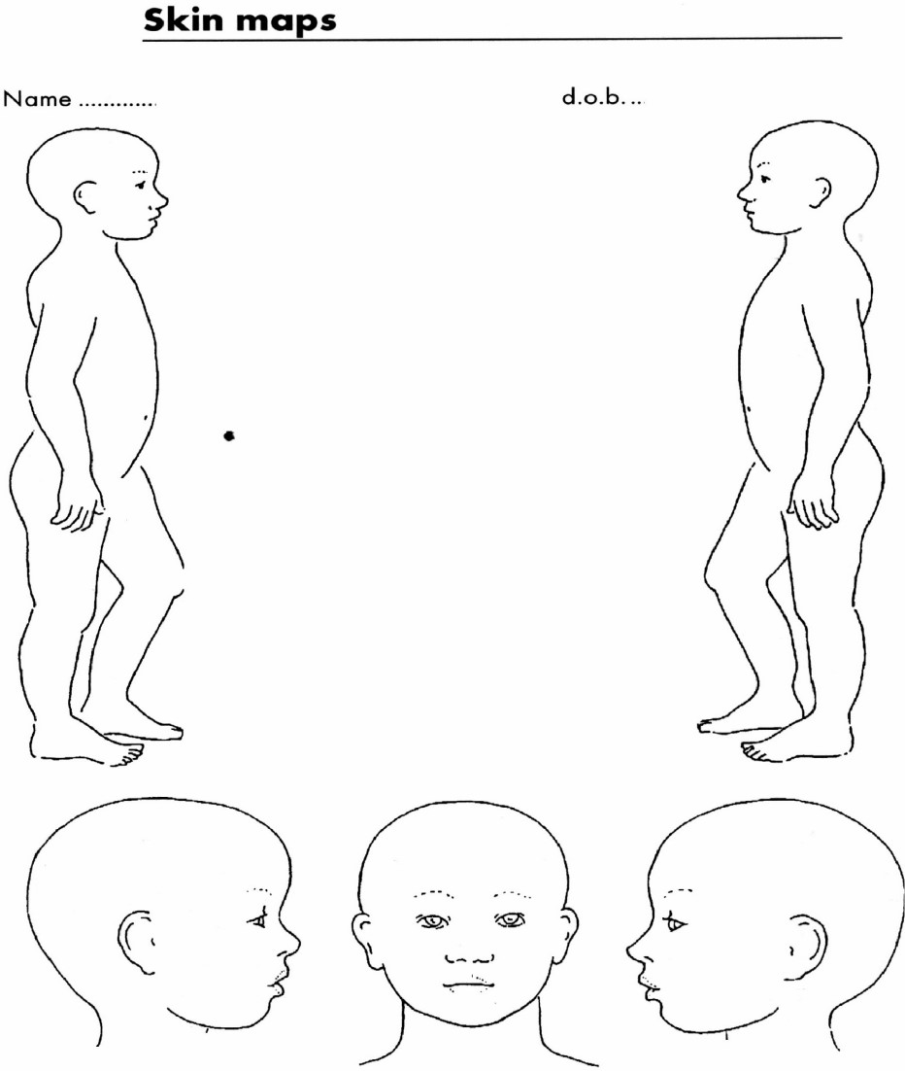

Signature ………………………………………. Date ………………………………………………………
Time of Incident: ………………………………………. Time Injuries identified ……………………………
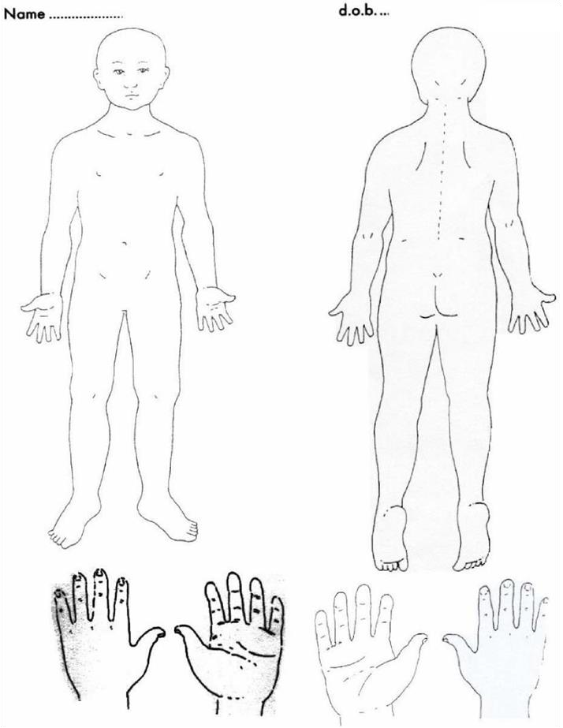

Signature ………………………………………. Date ………………………………………………………
Time of incident …………… Time injuries Identified…………………………………………

Ap#

#FOR SUPPLY STAFF ONLY
This form is not to be used for allegations against staff.
PART 1: INTERNAL NOTIFICATION of CP/WELFARE CONCERN TO THE DSL
DATE and TIME of CONCERN |  | date time
Name(s) of child/young person

D.O.B.
What is the nature of your concern
To consider:
- What is the nature of your concern
- How did this come about
- Where is this said to have taken place
- When did it happen
- Who is involved
MAKE SURE THAT YOU INCLUDE THE WISHES & FEELINGS OF THE CHILD IN THE RECORD i.e. how do you feel now, what do you want to happen?
Details
C360
Log no:

For DSL use only

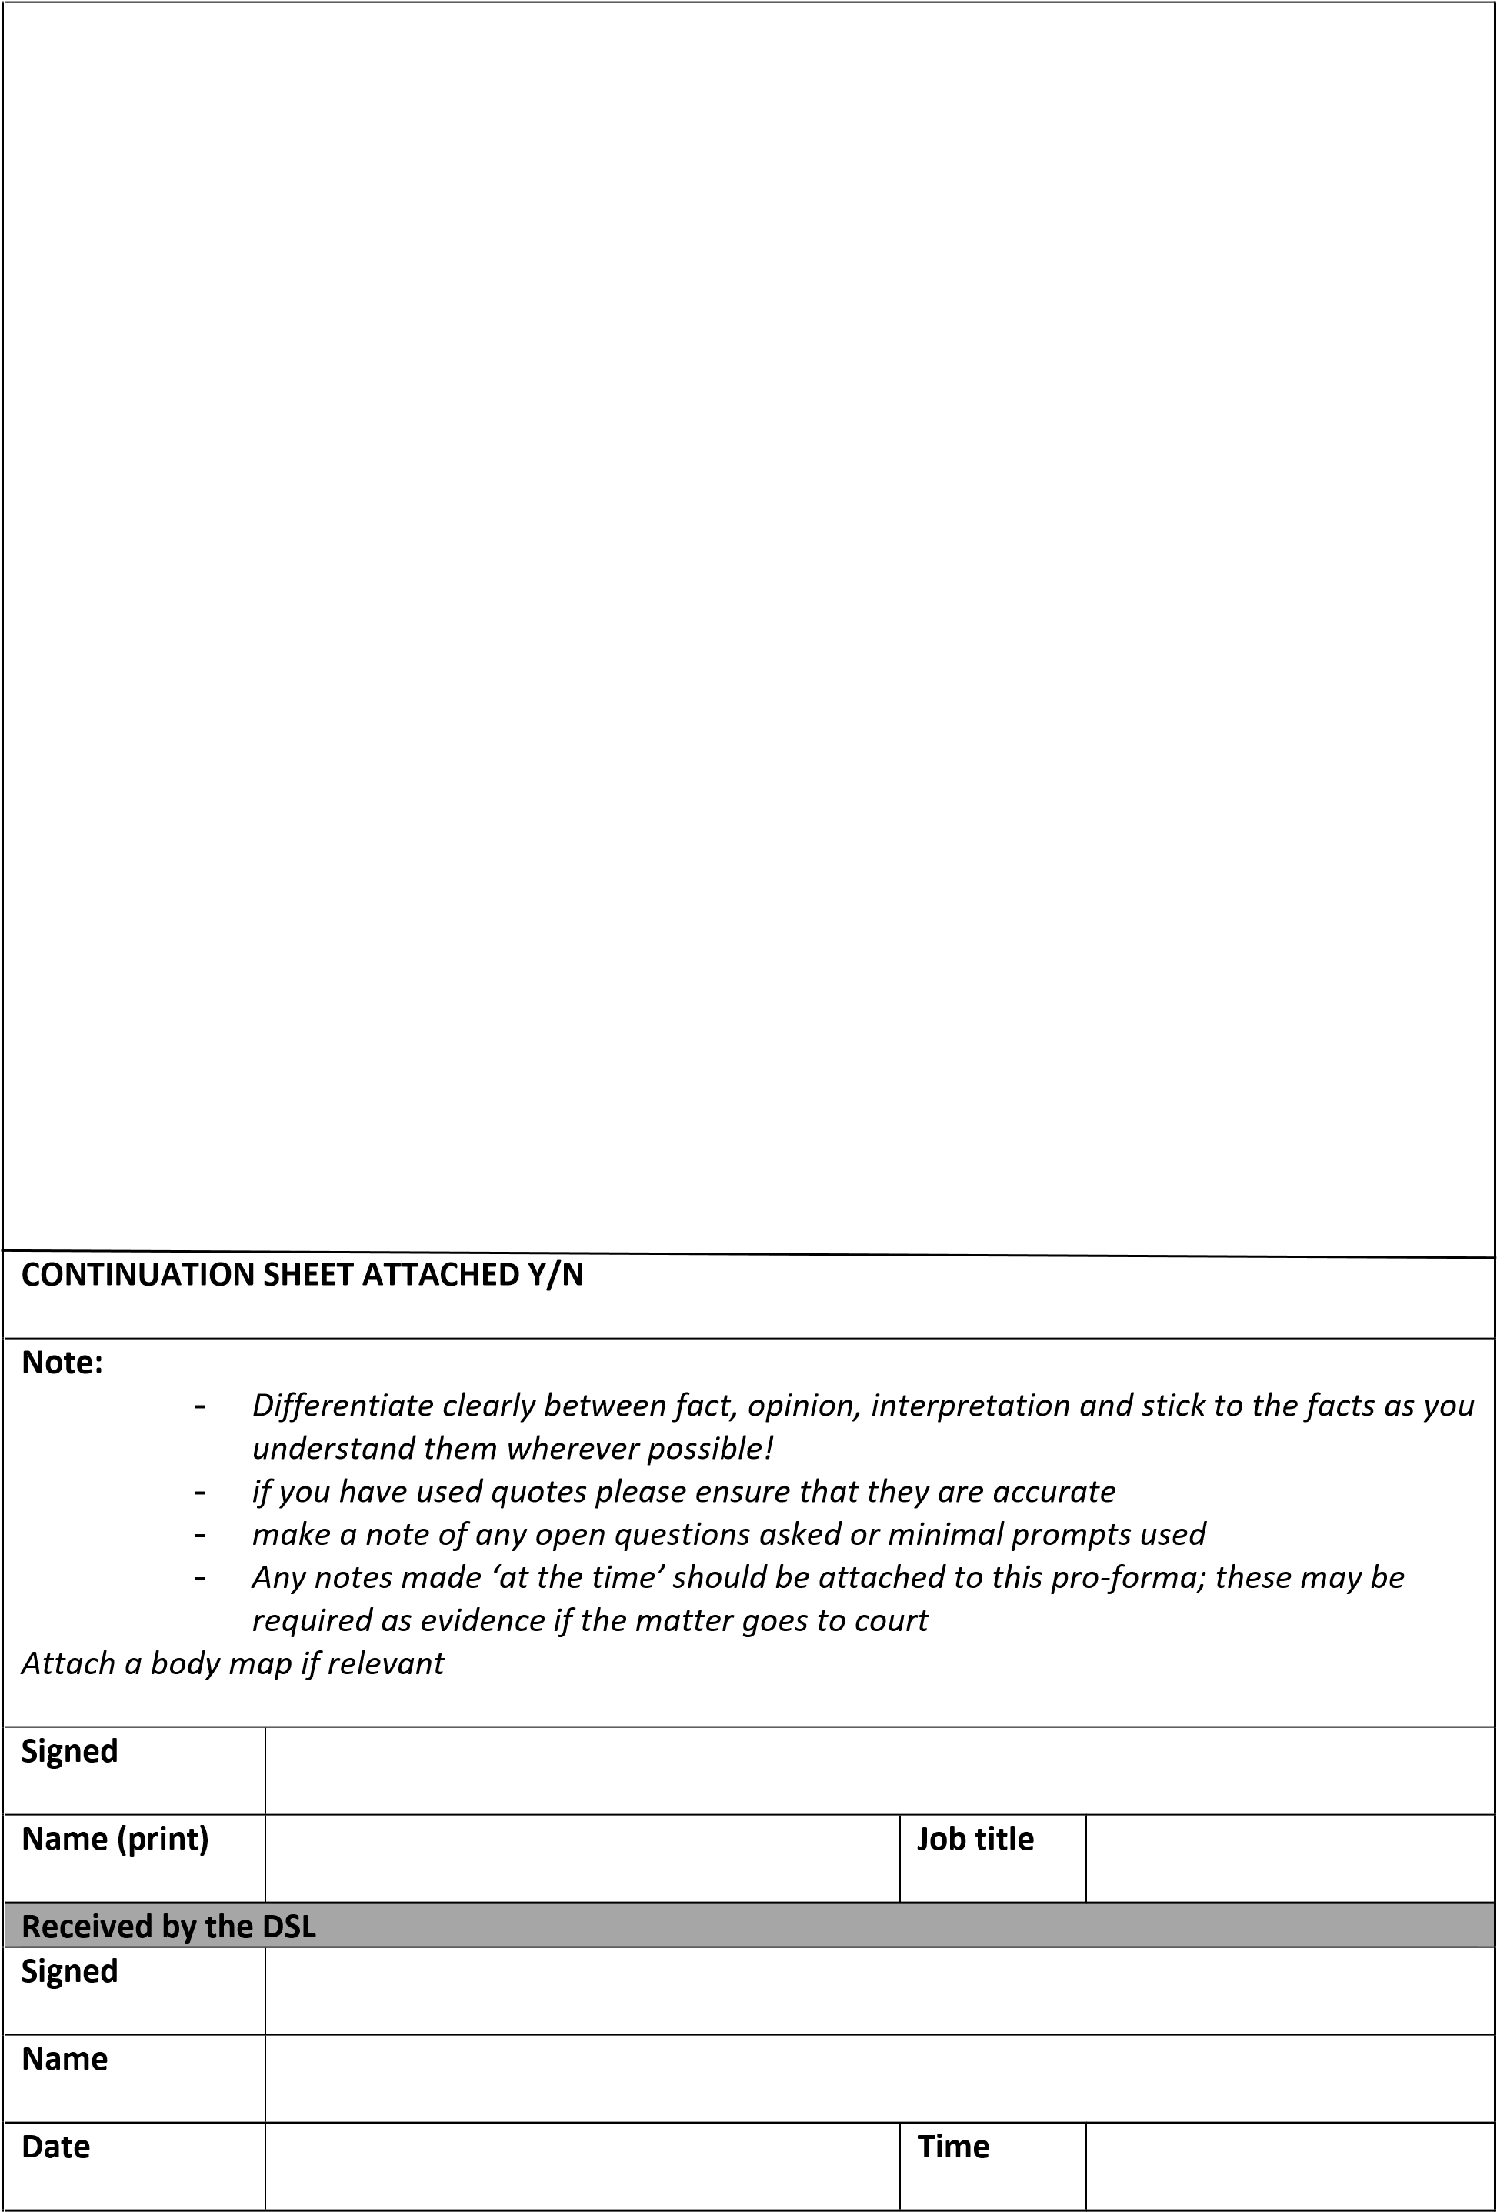

Record of Professional/Parent Contact
Date and time
Name of child/young person

D.O.B.
Name of
Professional/Parent
(Delete as appropriate)
Designation (if applicable)
Agency (if applicable)
Telephone number
Record of the conversation
Any action agreed

Signed
Name

Job Title

Information/concerns ‘Checklist’

- Does/could the suspected harm meet the LSCP definitions of abuse?
- Are there cultural, linguistic or disability issues?
- I am wrongly attributing something to impairment?
- Does the chronology indicate any possible patterns which could/do impact upon the level of risk?
- Are any injuries or incidents acute, cumulative, episodic?
- Did any injuries result from spontaneous action, neglect, or intent?
- Explanations consistent with injuries/behaviour?
- Severity and duration of any harm?
- Effects upon the child’s health/development?
- Immediate/longer term effects?
- Likelihood of recurrence?
- Child’s reaction?
- Child’s perception of the harm?
- Child’s needs wishes and feelings?
- Parent’s/carer’s attitudes/response to concerns?
- How willing are they to cooperate?
- What does the child mean to the family?
- What role does the child play?
- Possible effects of intervention?
- Protective factors and strengths of/for child (i.e. resilience/vulnerability)
- Familial strengths and weaknesses?
- Possibilities?
- Probabilities?
- When and how is the child at risk?
- How imminent is any likely risk?
- How grave are the possible consequences?
- How safe is this child?
- What are the risk assessment options?
- What are the risk management options?
- What is the interim plan?

KCSIE – September 2021 Updates

KCSIE September 2021 update
This guidance replaces Keeping Children Safe in Education September 2020.
- Part 1 Safeguarding information for all staff. In particular, there are changes as to what staff should be aware of and look out for, including peer on peer abuse; child criminal or sexual exploitation; the risk of online abuse; the sharing of nudes; and mental health concerns.
- Part 2 The management of safeguarding. There are substantial changes to Part 2. This includes changes to emphasise the need for a whole school approach to safeguarding; strengthened systems that should be in place; added information that schools should include in their child protection policy; clarity about powers to hold and use information; emphasis on online safety, including the importance of training for staff and what children should be taught; new paragraphs regarding safeguarding requirements when letting / hiring the school land; and new paragraphs regarding elective home education.
- Part 3 Safer recruitment. The DfE states that the whole of Part 3 has been substantively restructured to align it with the recruitment process, but that the legal duties have not changed. It provides various clarifications, including when certain checks should be carried out.
- Part 4 Allegations made against / concerns raised in relation to teachers, including supply teachers, other staff and contractors. This Part has been separated into two sections: the first for allegations that may meet the threshold, and the second for allegations / concerns that do not (i.e. low-level concerns). Further information is provided in relation to handling either type of allegation.
- Part 5 Child on child sexual violence and harassment. There is updated information in this Part, including in relation to responding to and managing a report, and supporting a victim or someone who has made allegations. This Part should be read alongside the separate updated DfE ‘Sexual violence and sexual harassment’ advice.

